Item ID Number: 30003050
Directions:
Passage or Graphic:
Stem: Which of these is a triangle?
Option A.

Option B.

Option C.

Option D.

Option E.

Key: D
RIT Range: 160 Goal 3.5.2
Copyright Info:
Idaho Content Alignment: 301.01.a
Learning Cont. Goal: Geometry
Learning Cont. Subgoal: Shapes and figures, 2 and 3-dimensional
Learning Cont. Bullet #: 1
Learning Cont. Page #: 1
Idaho Falls Content Alignment: Grade level 1-2, Abacus 37, 119
Item Entry Complete: Y

Item ID Number: 30003060
Directions:
Passage or Graphic:
Stem: Which is the same shape and size as ?

Option A.

Option B.

Option C.

Option D.

Option E.

Key: C
RIT Range: 160 Goal 3.8
Copyright Info:
Idaho Content Alignment: 301.01.b
Learning Cont. Goal: Geometry
Learning Cont. Subgoal: Congruency and Similarity
Learning Cont. Bullet #: 1
Learning Cont. Page #: 1
Idaho Falls Content Alignment: Grade Level 1-2, Abacus?
Item Entry Complete: Y

Item ID Number: 30003080
Directions:
Passage or Graphic:
Stem: Which is a cone?
Option A.
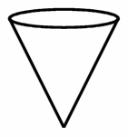
Option B.

Option C.
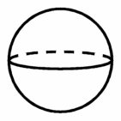
Option D.

Option E.
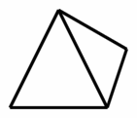
Key: A
RIT Range: 170 Goal 3.6
Copyright Info:
Idaho Content Alignment: 301.01a
Learning Cont. Goal: Geometry
Learning Cont. Subgoal: Shapes and figures 2 and 3-dimensional
Learning Cont. Bullet #: 1
Learning Cont. Page #: 1
Idaho Falls Content Alignment: grade level 3, 156
Item Entry Complete: Y

Item ID Number: 30003090
Directions: Choose the shape with all square sides.
Passage or Graphic:
Stem:
Option A.
Option B.

Option C.
Option D.
Option E.

Key: B
RIT Range: 170 Goal 3.6.2.1
Copyright Info:
Idaho Content Alignment: 301.01a
Learning Cont. Goal: Geometry
Learning Cont. Subgoal: Shapes and Figures, 2 or 3-dimensional
Learning Cont. Bullet #: 2
Learning Cont. Page #: 1
Idaho Falls Content Alignment: “None”
Item Entry Complete: Y

Item ID Number: 30003100
Directions:
Passage or Graphic:
Stem:
How many sides?

Option A. 2
Option B. 4
Option C. 3
Option D. 1
Option E. 5
Key: C
RIT Range: 170 Goal 3.5
Copyright Info:
Idaho Content Alignment: 301.01a
Learning Cont. Goal: Geometry
Learning Cont. Subgoal: Shapes and Figures, 2 and 3-dimensional
Learning Cont. Bullet #: 3
Learning Cont. Page #: 1
Idaho Falls Content Alignment: grade level 2, 119
Item Entry Complete: Y

Item ID Number: 30003110
Directions:
Passage or Graphic:
Stem: Which is a closed figure?
Option A.
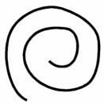
Option B.
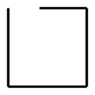
Option C.
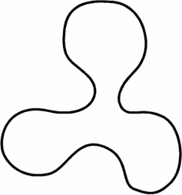
Option D.
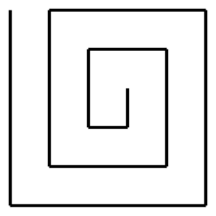
Option E.
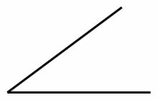
Key: C
RIT Range: 170 Goal 3.12
Copyright Info:
Idaho Content Alignment: 301.01b
Learning Cont. Goal: Geometry
Learning Cont. Subgoal: Shapes and figures, 2 and 3-dimensional
Learning Cont. Bullet #: 4
Learning Cont. Page #: 1
Idaho Falls Content Alignment: “None”
Item Entry Complete: Y

Item ID Number: 30003120
Directions:
Passage or Graphic:
Stem:
A can has

Option A. two circles.
Option B. square sides.
Option C. two triangles.
Option D. a rectangle side.
Option E. two square sides.
Key: A
RIT Range: 170 Goal 3.6.2.4
Copyright Info:
Idaho Content Alignment: 301.01a
Learning Cont. Goal: Geometry
Learning Cont. Subgoal: Shapes and Figures, 2 and 3-dimensional
Learning Cont. Bullet #: 5
Learning Cont. Page #: 1
Idaho Falls Content Alignment: grade level 3, 156
Item Entry Complete: Y

Item ID Number: 30003140
Directions:
Passage or Graphic:
Stem: Which are cylinders?
Option A. shoeboxes
Option B. baseballs
Option C. dice
Option D. soup cans
Option E. books
Key: D
RIT Range: 180 Goal 3.6.2.4
Copyright Info:
Idaho Content Alignment: 301.01.b
Learning Cont. Goal: Geometry
Learning Cont. Subgoal: Shapes and Figures...
Learning Cont. Bullet #: 1
Learning Cont. Page #: 1
Idaho Falls Content Alignment: Grade 3, #156
Item Entry Complete: Y

Item ID Number: 30003150
Directions:
Passage or Graphic:
Stem: Which shape is the same size and shape (congruent) to 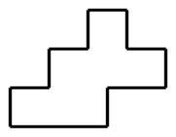?
Option A.
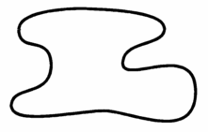
Option B.
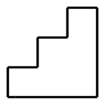
Option C.
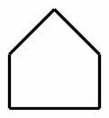
Option D.
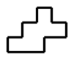
Option E.
Key: E
RIT Range: 170 Goal 3.8
Copyright Info:
Idaho Content Alignment: 301.01.b
Learning Cont. Goal: Geometry
Learning Cont. Subgoal: Congruency & Similarity
Learning Cont. Bullet #: 1
Learning Cont. Page #: 1
Idaho Falls Content Alignment: Grade 4, #165
Item Entry Complete: Y

Item ID Number: 30003160
Directions:
Passage or Graphic:
Stem: Which of these shows a flip?
Option A.
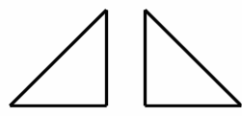
Option B.
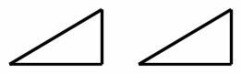
Option C.
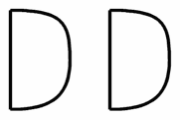
Option D.
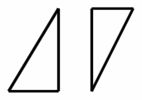
Option E.
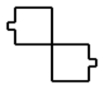
Key: A
RIT Range: 180 Goal 3.3.4
Copyright Info:
Idaho Content Alignment: 301.01.d
Learning Cont. Goal: Geometry
Learning Cont. Subgoal: Symmetry & Transformations
Learning Cont. Bullet #: 1
Learning Cont. Page #: 1
Idaho Falls Content Alignment: "no match"
Item Entry Complete: Y

Item ID Number: 30003170
Directions:
Passage or Graphic:

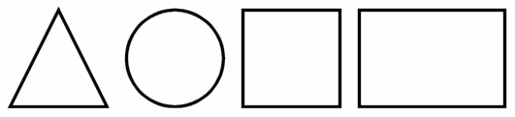

Stem: From left to right, what are these figures?
Option A. circle, square, rectangle, triangle
Option B. square, rectangle, triangle, circle
Option C. rectangle, triangle, circle, square
Option D. triangle, circle, square, rectangle
Option E. triangle, circle, rectangle, square
Key: D
RIT Range: 190 Goal 3.5.2
Copyright Info:
Idaho Content Alignment: 301.01.a
Learning Cont. Goal: Geometry
Learning Cont. Subgoal: Shapes & Figures...
Learning Cont. Bullet #: 1
Learning Cont. Page #: 1
Idaho Falls Content Alignment: Grade 2
Item Entry Complete: Y

Item ID Number: 30003180
Directions:
Passage or Graphic:
Stem: Which is a cube?
Option A.
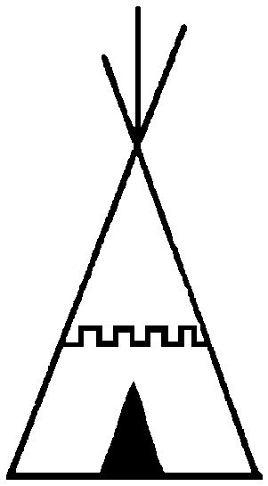
Option B.
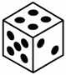
Option C.
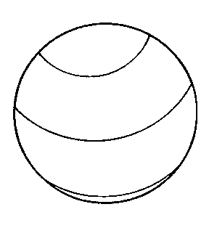
Option D.
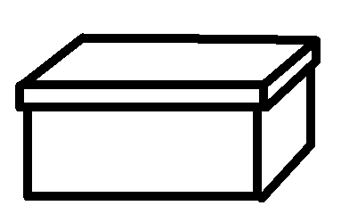
Option E.
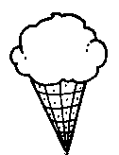
Key: B
RIT Range: 190 Goal 3.6.2.1
Copyright Info:
Idaho Content Alignment: 301.01.a
Learning Cont. Goal: Geometry
Learning Cont. Subgoal: Shapes & Figures...
Learning Cont. Bullet #: 2
Learning Cont. Page #: 1
Idaho Falls Content Alignment: Grade 3, #156
Item Entry Complete: Y

Item ID Number: 30003190
Directions:
Passage or Graphic:
Stem: What has three sides and three corners?
Option A. cube
Option B. triangle
Option C. square
Option D. rectangle
Option E. sphere
Key: B
RIT Range: 190 Goal 3.5
Copyright Info:
Idaho Content Alignment: 301.01.a
Learning Cont. Goal: Geometry
Learning Cont. Subgoal: Shapes & Figures...
Learning Cont. Bullet #: 3
Learning Cont. Page #: 1
Idaho Falls Content Alignment: Grade 3, #156
Item Entry Complete: Y

Item ID Number: 30003200
Directions:
Passage or Graphic:
Stem: Which pair of angles are the same size and shape (congruent)?
Option A.
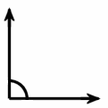
Option B.
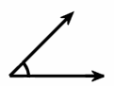
Option C.
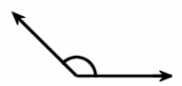
Option D.
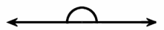
Option E.
Key: A
RIT Range: 181 Goal 3.11.2
Copyright Info:
Idaho Content Alignment: 301.01.b
Learning Cont. Goal: Geometry
Learning Cont. Subgoal: Congruency & Similarity
Learning Cont. Bullet #: 1
Learning Cont. Page #: 1
Idaho Falls Content Alignment: "no match through 5th"
Item Entry Complete: Y

Item ID Number: 30003210
Directions:
Passage or Graphic:
Stem: Which figures are similar but not the same size and shape (congruent)?
Option A.
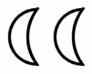
Option B.
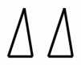
Option C.
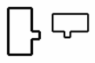
Option D.
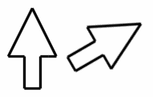
Option E.
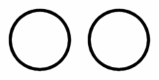
Key: C
RIT Range: 181 Goal 3.9
Copyright Info:
Idaho Content Alignment: 301.01.b
Learning Cont. Goal: Geometry
Learning Cont. Subgoal: Congruency & Similarity
Learning Cont. Bullet #: 3
Learning Cont. Page #: 2
Idaho Falls Content Alignment: Grade 4, #165
Item Entry Complete: Y

Item ID Number: 30003220
Directions:
Passage or Graphic:

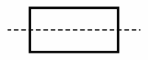 | 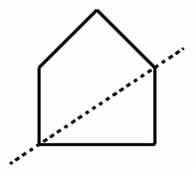 | 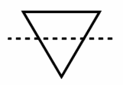 | 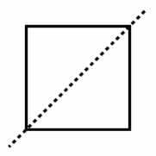 | 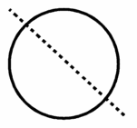
1 | 2 | 3 | 4 | 5

Stem: Which figures show a line of symmetry?
Option A. 1, 4, and 5
Option B. 2, 4, and 5
Option C. 4 and 5
Option D. 1 and 4
Option E. 2, 3, and 4
Key: A
RIT Range: 181 Goal 3.1
Copyright Info:
Idaho Content Alignment: 301.01.b
Learning Cont. Goal: Geometry
Learning Cont. Subgoal: Symmetry & Transformation
Learning Cont. Bullet #: 1
Learning Cont. Page #: 2
Idaho Falls Content Alignment: Grade 6, #112
Item Entry Complete: Y

Item ID Number: 30003230
Directions:
Passage or Graphic:

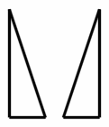 | 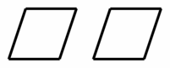 | 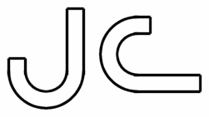 | 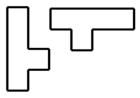 | 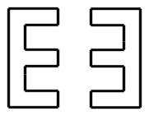
1 | 2 | 3 | 4 | 5

Stem: Which of these represents an object being turned?
Option A. 1, 4 and 5
Option B. 3 and 4
Option C. 1, 2 and 3
Option D. 2 and 3
Option E. 3, 4 and 5
Key: B
RIT Range: 181 Goal 3.3.1
Copyright Info:
Idaho Content Alignment: 301.01.d
Learning Cont. Goal: Geometry
Learning Cont. Subgoal: Symmetry and Transformations
Learning Cont. Bullet #: 2
Learning Cont. Page #: 2
Idaho Falls Content Alignment: Grade 7+
Item Entry Complete: Y

Item ID Number: 30003240
Directions:
Passage or Graphic:

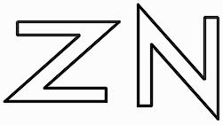

Stem: The figure on the left has been moved to get the figure on the right. This is an example of a ________.
Option A. symmetry
Option B. flip
Option C. turn
Option D. congruency
Option E. slide
Key: C
RIT Range: 190 Goal 3.3.1
Copyright Info:
Idaho Content Alignment: 301.01.d
Learning Cont. Goal: Geometry
Learning Cont. Subgoal: Symmetry & Transformations
Learning Cont. Bullet #: 3
Learning Cont. Page #: 2
Idaho Falls Content Alignment: Grade 7+
Item Entry Complete: Y

Item ID Number: 30003250
Directions:
Passage or Graphic:

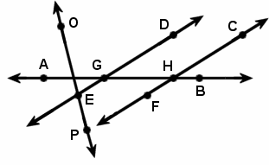

Stem: Which point is on line DE?
Option A. P
Option B. A
Option C. C
Option D. G
Option E. H
Key: D
RIT Range: 190 Goal 3.2
Copyright Info:
Idaho Content Alignment: 341.01.c
Learning Cont. Goal: Geometry
Learning Cont. Subgoal: Line Properties & Terminology
Learning Cont. Bullet #: 1
Learning Cont. Page #: 2
Idaho Falls Content Alignment: Grade 6, #106, 112
Item Entry Complete: Y

Item ID Number: 30003270
Directions:
Passage or Graphic:
Stem: Which of these is a sphere?
Option A.
Option B.
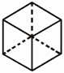
Option C.
Option D.
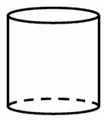
Option E.
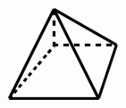
Key: A
RIT Range: 200 Goal 3.6
Copyright Info:
Idaho Content Alignment: 341.01.a
Learning Cont. Goal: Geometry
Learning Cont. Subgoal: Shapes & Figures...
Learning Cont. Bullet #: 1
Learning Cont. Page #: 2
Idaho Falls Content Alignment: Grade 4, #155
Item Entry Complete: Y

Item ID Number: 30003300
Directions:
Passage or Graphic:

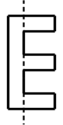 | 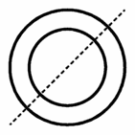 | 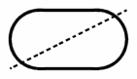 | 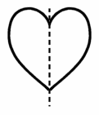 | 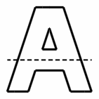
1 | 2 | 3 | 4 | 5

Stem: Which figures show a line of symmetry?
Option A. 2, 3 and 4
Option B. 2 only
Option C. 1 and 2
Option D. 2 and 4
Option E. 3, 4 and 5
Key: D
RIT Range: 191 Goal 3.1
Copyright Info:
Idaho Content Alignment: 301.01.b
Learning Cont. Goal: Geometry
Learning Cont. Subgoal: Symmetry & Transformations
Learning Cont. Bullet #: 1
Learning Cont. Page #: 2
Idaho Falls Content Alignment: Grade 6, #112
Item Entry Complete: Y

Item ID Number: 30003310
Directions:
Passage or Graphic:

A B C D E F G

Stem: Which letter is in the middle?
Option A. E
Option B. C
Option C. A
Option D. G
Option E. D
Key: E
RIT Range: 170 Goal 3.4
Copyright Info:
Idaho Content Alignment: 341.01.c
Learning Cont. Goal: Geometry
Learning Cont. Subgoal: Geometric Properties & Terminology
Learning Cont. Bullet #: 1
Learning Cont. Page #: 2
Idaho Falls Content Alignment: "N.A."
Item Entry Complete: Y

Item ID Number: 30003330
Directions:
Passage or Graphic:

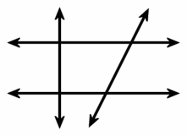

Stem: How many right angles are in the diagram?
Option A. 2
Option B. 8
Option C. 4
Option D. 16
Option E. 6
Key: B
RIT Range: 200 Goal 3.11.10
Copyright Info:
Idaho Content Alignment: 341.01.b
Learning Cont. Goal: Geometry
Learning Cont. Subgoal: Geometric Properties & Terminology
Learning Cont. Bullet #: 3
Learning Cont. Page #: 2
Idaho Falls Content Alignment: Grade 6, #122
Item Entry Complete: Y

Item ID Number: 30003340
Directions:
Passage or Graphic:

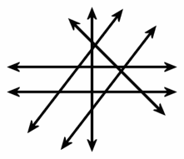

Stem: How many sets of parallel lines are in the figure?
Option A. 1
Option B. 0
Option C. 2
Option D. 5
Option E. 3
Key: C
RIT Range: 200 Goal 3.2.1
Copyright Info:
Idaho Content Alignment: 341.01.c
Learning Cont. Goal: Geometry
Learning Cont. Subgoal: Geometric Properties & Terminology
Learning Cont. Bullet #: 4
Learning Cont. Page #: 2
Idaho Falls Content Alignment: Grade 6, #112
Item Entry Complete: Y

Item ID Number: 30003350
Directions:
Passage or Graphic:
Stem: Which figure shows a diagonal?
Option A.
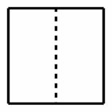
Option B.
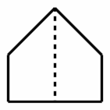
Option C.
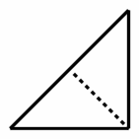
Option D.
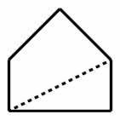
Option E.
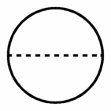
Key: D
RIT Range: 200 Goal 3.4
Copyright Info:
Idaho Content Alignment: "341.01.c (?), 341.01.j (?)"
Learning Cont. Goal: Geometry
Learning Cont. Subgoal: Geometric Properties & Terminology
Learning Cont. Bullet #: 5
Learning Cont. Page #: 2
Idaho Falls Content Alignment: Grade 8
Item Entry Complete: Y

Item ID Number: 30003360
Directions:
Passage or Graphic:

Stem: How many edges are there on a square pyramid?
Option A. 4
Option B. 6
Option C. 5
Option D. 7
Option E. 8
Key: E
RIT Range: 210 Goal 3.6.2.3
Copyright Info:
Idaho Content Alignment: 301.01.a, 341.01.a
Learning Cont. Goal: Geometry
Learning Cont. Subgoal: Shapes & Figures...
Learning Cont. Bullet #: 1
Learning Cont. Page #: 2
Idaho Falls Content Alignment: Grade 5, #70
Item Entry Complete: Y

Item ID Number: 30003370
Directions:
Passage or Graphic:
Stem: Which of these polygons is a pentagon?
Option A.
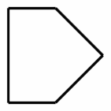
Option B.
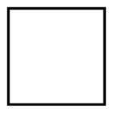
Option C.
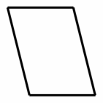
Option D.
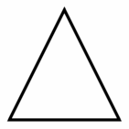
Option E.
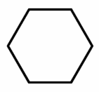
Key: A
RIT Range: 201 Goal 3.5.2
Copyright Info:
Idaho Content Alignment: 301.01.a, 341.01.a
Learning Cont. Goal: Geometry
Learning Cont. Subgoal: Shapes & Figures...
Learning Cont. Bullet #: 2
Learning Cont. Page #: 2
Idaho Falls Content Alignment: Grade 4, #154; Grade 5, #70
Item Entry Complete: Y

Item ID Number: 30003380
Directions:
Passage or Graphic:
Stem: Which figure is not a quadrilateral?
Option A.
Option B.
Option C.
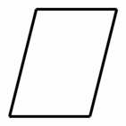
Option D.
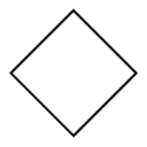
Option E.
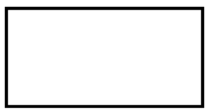
Key: B
RIT Range: 201 Goal 3.5.2
Copyright Info:
Idaho Content Alignment: 301.01.a, 341.01.a
Learning Cont. Goal: Geometry
Learning Cont. Subgoal: Shapes & Figures...
Learning Cont. Bullet #: 3
Learning Cont. Page #: 2
Idaho Falls Content Alignment: Grade 4, #154; Grade 5, #70
Item Entry Complete: Y

Item ID Number: 30003390
Directions:
Passage or Graphic:
Stem: You can make a cylinder with ________.
Option A. three circles
Option B. one circle and a cone
Option C. two circles and a rectangle
Option D. one rectangle and two squares
Option E. two circles
Key: C
RIT Range: 201 Goal 3.6.2.4
Copyright Info:
Idaho Content Alignment: 301.01.a, 341.01.a
Learning Cont. Goal: Geometry
Learning Cont. Subgoal: Shapes & Figures...
Learning Cont. Bullet #: 4
Learning Cont. Page #: 2
Idaho Falls Content Alignment: Grade 4, #155; Grade 5, #70
Item Entry Complete: Y

Item ID Number: 30003400
Directions:
Passage or Graphic:
Stem: Which figures are mirror images (reflections) of each other?
Option A.
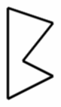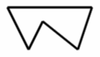
Option B.
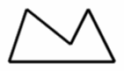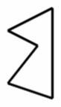
Option C.
Option D.
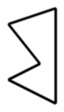
Option E.
Key: D
RIT Range: 201 Goal 3.3.4
Copyright Info:
Idaho Content Alignment: 301.01.d, 341.01.g
Learning Cont. Goal: Geometry
Learning Cont. Subgoal: Symmetry & Transformations
Learning Cont. Bullet #: 1
Learning Cont. Page #: 2
Idaho Falls Content Alignment: Grade 7+
Item Entry Complete: Y

Item ID Number: 30003410
Directions:
Passage or Graphic:

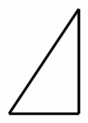 | 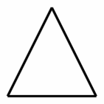 | 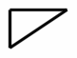 | 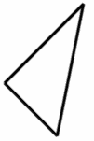 | 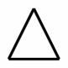
1 | 2 | 3 | 4 | 5

Stem: Which two figures are similar but not congruent?
Option A. 1 and 4
Option B. 2 and 4
Option C. 3 and 5
Option D. 1 and 2
Option E. 1 and 3
Key: E
RIT Range: 210 Goal 3.9
Copyright Info:
Idaho Content Alignment: 341.01.d, 341.01.c, 301.01.b
Learning Cont. Goal: Geometry
Learning Cont. Subgoal: Congruency & Similarity
Learning Cont. Bullet #: 1
Learning Cont. Page #: 2
Idaho Falls Content Alignment: Grade 4, #165; Grade 6, #102, 112
Item Entry Complete: Y

Item ID Number: 30003420
Directions:
Passage or Graphic:

Stem: This figure is a picture of ________.
Option A. a ray
Option B. an angle
Option C. a line
Option D. an acute angle
Option E. a line segment
Key: A
RIT Range: 210 Goal 3.2
Copyright Info:
Idaho Content Alignment: 341.01.c
Learning Cont. Goal: Geometry
Learning Cont. Subgoal: Geometric Properties & Terminology
Learning Cont. Bullet #: 1
Learning Cont. Page #: 2
Idaho Falls Content Alignment: Grade 6, #106, 112
Item Entry Complete: Y

Item ID Number: 30003440
Directions:
Passage or Graphic:
Stem: Which of these shows parallel lines?
Option A.
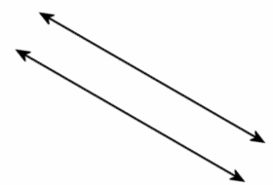
Option B.
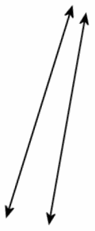
Option C.
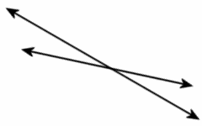
Option D.
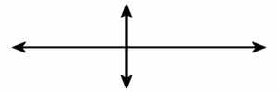
Option E.
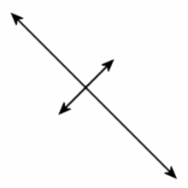
Key: A
RIT Range: 201 Goal 3.2.1
Copyright Info:
Idaho Content Alignment: 341.01.c
Learning Cont. Goal: Geometry
Learning Cont. Subgoal: Geometric Properties & Terminology
Learning Cont. Bullet #: 1
Learning Cont. Page #: 3
Idaho Falls Content Alignment: Grade 6, #112
Item Entry Complete: Y

Item ID Number: 30003450
Directions:
Passage or Graphic:

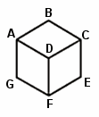

Stem: Which of these represents a face on the cube?
Option A. point A
Option B. plane ABCD
Option C. segment AD
Option D. segment CG
Option E. segment DE
Key: B
RIT Range: 211 Goal 3.6.2.1
Copyright Info:
Idaho Content Alignment: 341.01.a
Learning Cont. Goal: Geometry
Learning Cont. Subgoal: Shapes & Figures...
Learning Cont. Bullet #: 1
Learning Cont. Page #: 3
Idaho Falls Content Alignment: "None"
Item Entry Complete: Y

Item ID Number: 30003470
Directions:
Passage or Graphic:
Stem: What is the name of a polygon with six sides?
Option A. triangle
Option B. quadrilateral
Option C. pentagon
Option D. hexagon
Option E. octagon
Key: D
RIT Range: 211 Goal 3.5.2
Copyright Info:
Idaho Content Alignment: 341.01.a
Learning Cont. Goal: Geometry
Learning Cont. Subgoal: Shapes & Figures...
Learning Cont. Bullet #: 3
Learning Cont. Page #: 3
Idaho Falls Content Alignment: "None"
Item Entry Complete: Y

Item ID Number: 30003480
Directions:
Passage or Graphic:
Stem: Which of these figures is a quadrilateral?
Option A.
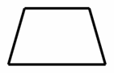
Option B.
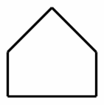
Option C.
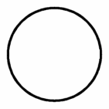
Option D.
Option E.
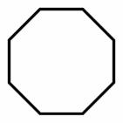
Key: A
RIT Range: 211 Goal 3.5.2
Copyright Info:
Idaho Content Alignment: 341.01.a
Learning Cont. Goal: Geometry
Learning Cont. Subgoal: Shapes & Figures...
Learning Cont. Bullet #: 4
Learning Cont. Page #: 3
Idaho Falls Content Alignment: "None"
Item Entry Complete: Y

Item ID Number: 30003490
Directions:
Passage or Graphic:

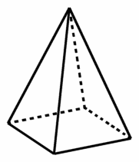

Stem: How many vertices does a rectangular pyramid have?
Option A. 4
Option B. 5
Option C. 6
Option D. 7
Option E. 8
Key: B
RIT Range: 211 Goal 3.6.2.3
Copyright Info:
Idaho Content Alignment: 341.01.a
Learning Cont. Goal: Geometry
Learning Cont. Subgoal: Shapes & Figures...
Learning Cont. Bullet #: 5
Learning Cont. Page #: 3
Idaho Falls Content Alignment: "None"
Item Entry Complete: Y

Item ID Number: 30003500
Directions:
Passage or Graphic:
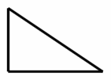
Stem: Which of these is similar to the given figure?
Option A.
Option B.
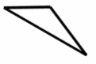
Option C.
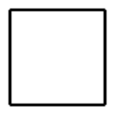
Option D.
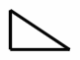
Option E.
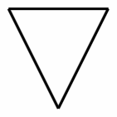
Key: D
RIT Range: 211 Goal 3.7.8
Copyright Info:
Idaho Content Alignment: 341.01.c
Learning Cont. Goal: Geometry
Learning Cont. Subgoal: Congruency & Similarity
Learning Cont. Bullet #: 1
Learning Cont. Page #: 3
Idaho Falls Content Alignment: "None"
Item Entry Complete: Y

Item ID Number: 30003510
Directions:
Passage or Graphic:

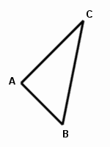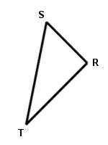

Stem: Which of these is a pair of corresponding sides?
Option A. AB and TR
Option B. BC and ST
Option C. AB and BC
Option D. TR and TS
Option E. AB and TS
Key: B
RIT Range: 220 Goal 3.11.4
Copyright Info:
Idaho Content Alignment: 341.01.d
Learning Cont. Goal: Geometry
Learning Cont. Subgoal: Congruency & Similarity
Learning Cont. Bullet #: 2
Learning Cont. Page #: 3
Idaho Falls Content Alignment: "None"
Item Entry Complete: Y

Item ID Number: 30003520
Directions:
Passage or Graphic:

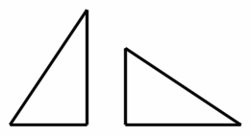

Stem: What type of transformation is shown?
Option A. Translation
Option B. Rotation
Option C. Reflection
Option D. Symmetry
Option E. Congruent
Key: B
RIT Range: 211 Goal 3.3.1
Copyright Info:
Idaho Content Alignment: 341.01.g, 351.01.a
Learning Cont. Goal: Geometry
Learning Cont. Subgoal: Symmetry & Transformations
Learning Cont. Bullet #: 1
Learning Cont. Page #: 3
Idaho Falls Content Alignment: “None”
Item Entry Complete: Y

Item ID Number: 30003540
Directions:
Passage or Graphic:

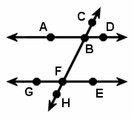

Stem: Which of these is an acute angle in the figure?
Option A. angle GFB
Option B. angle DBF
Option C.
Option D.
Option E. angle ABC
Key: D
RIT Range: 220 Goal 3.11.7
Copyright Info:
Idaho Content Alignment: 341.01.c
Learning Cont. Goal: Geometry
Learning Cont. Subgoal: Geometric Properties & Terminology
Learning Cont. Bullet #: 2
Learning Cont. Page #: 3
Idaho Falls Content Alignment: "None"
Item Entry Complete: Y

Item ID Number: 30003550
Directions:
Passage or Graphic:

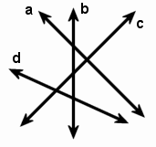

Stem: Which two lines are perpendicular?
Option A. a and b
Option B. a and c
Option C. b and c
Option D. d and b
Option E. a and d
Key: B
RIT Range: 220 Goal 3.2.2
Copyright Info:
Idaho Content Alignment: 341.01.c
Learning Cont. Goal: Geometry
Learning Cont. Subgoal: Geometric Properties & Terminology
Learning Cont. Bullet #: 3
Learning Cont. Page #: 3
Idaho Falls Content Alignment: "None"
Item Entry Complete: Y

Item ID Number: 30003570
Directions:
Passage or Graphic:
Stem: Which of these has a rectangular base and four triangular faces?
Option A. cube
Option B. rectangular prism
Option C. triangular prism
Option D. rectangular pyramid
Option E. triangular pyramid
Key: D
RIT Range: 221 Goal 3.6.2.3
Copyright Info:
Idaho Content Alignment: 341.01.a
Learning Cont. Goal: Geometry
Learning Cont. Subgoal: Shapes & Figures...
Learning Cont. Bullet #: 1
Learning Cont. Page #: 3
Idaho Falls Content Alignment: "None"
Item Entry Complete: Y

Item ID Number: 30003580
Directions:
Passage or Graphic:
Stem: Which type of polygon has exactly one pair of opposite sides parallel?
Option A. triangle
Option B. square
Option C. trapezoid
Option D. parallelogram
Option E. rhombus
Key: C
RIT Range: 221 Goal 3.5.2
Copyright Info:
Idaho Content Alignment: 341.01.a
Learning Cont. Goal: Geometry
Learning Cont. Subgoal: Shapes & Figures...
Learning Cont. Bullet #: 2
Learning Cont. Page #: 3
Idaho Falls Content Alignment: "None"
Item Entry Complete: Y

Item ID Number: 30003590
Directions:
Passage or Graphic:

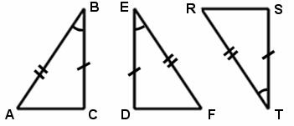

Stem: Which congruency statement is written correctly?
Option A.
Option B.
Option C.
Option D.
Option E.
Key: C
RIT Range: 221 Goal 3.7.7
Copyright Info:
Idaho Content Alignment: 341.01.d
Learning Cont. Goal: Geometry
Learning Cont. Subgoal: Congruency & Similarity
Learning Cont. Bullet #: 1
Learning Cont. Page #: 3
Idaho Falls Content Alignment: "None"
Item Entry Complete: Y

Item ID Number: 30003600
Directions:
Passage or Graphic:

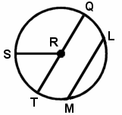

Stem: Which of these is a diameter of the circle?
Option A.
Option B.
Option C.
Option D.
Option E.
Key: C
RIT Range: 221 Goal 3.5.3
Copyright Info:
Idaho Content Alignment: 341.01.a, 341.01.c
Learning Cont. Goal: Geometry
Learning Cont. Subgoal: Geometric Properties & Terminology
Learning Cont. Bullet #: 1
Learning Cont. Page #: 3
Idaho Falls Content Alignment: "None"
Item Entry Complete: Y

Item ID Number: 30003610
Directions:
Passage or Graphic:

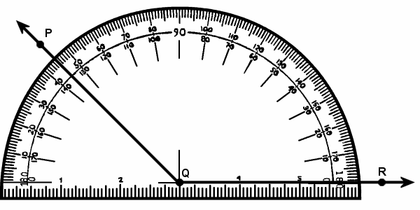

Stem: What is the measure of ?
Option A.
Option B.
Option C.
Option D.
Option E.
Key: B
RIT Range: 221 Goal 3.11.8
Copyright Info:
Idaho Content Alignment: 341.01.b
Learning Cont. Goal: Geometry
Learning Cont. Subgoal: Geometric Properties & Terminology
Learning Cont. Bullet #: 2
Learning Cont. Page #: 3
Idaho Falls Content Alignment: "None"
Item Entry Complete: Y

Item ID Number: 30003620
Directions:
Passage or Graphic:

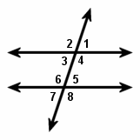

Stem: Which pair of angles is supplementary?
Option A. and
Option B. and
Option C. and
Option D. and
Option E. and
Key: A
RIT Range: 221 Goal 3.11.6
Copyright Info:
Idaho Content Alignment: 341.01.a
Learning Cont. Goal: Geometry
Learning Cont. Subgoal: Geometric Properties & Terminology
Learning Cont. Bullet #: 3
Learning Cont. Page #: 3
Idaho Falls Content Alignment: "None"
Item Entry Complete: Y

Item ID Number: 30003630
Directions:
Passage or Graphic:

Stem: Which pair of angles are vertical angles?
Option A. and
Option B. and
Option C. and
Option D. and
Option E. and
Key: B
RIT Range: 221 Goal 3.11.13
Copyright Info:
Idaho Content Alignment: 341.01.a
Learning Cont. Goal: Geometry
Learning Cont. Subgoal: Geometric Properties & Terminology
Learning Cont. Bullet #: 4
Learning Cont. Page #: 3
Idaho Falls Content Alignment: “None”
Item Entry Complete: Y

Item ID Number: 30003650
Directions:
Passage or Graphic:

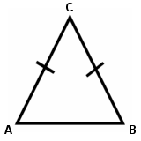

Stem: What type of triangle is this?
Option A. equilateral
Option B. isosceles
Option C. scalene
Option D. obtuse
Option E. right
Key: B
RIT Range: 231 Goal 3.7.3.1
Copyright Info:
Idaho Content Alignment: 341.01.a, 341.01.h
Learning Cont. Goal: Geometry
Learning Cont. Subgoal: Geometric Properties & Terminology
Learning Cont. Bullet #: 1
Learning Cont. Page #: 4
Idaho Falls Content Alignment: "291342"
Item Entry Complete: Y

Item ID Number: 30003660
Directions:
Passage or Graphic:
Stem: What type of polygon has eight sides?
Option A. quadrilateral
Option B. hexagon
Option C. pentagon
Option D. octagon
Option E. heptagon
Key: D
RIT Range: 220 Goal 3.5.2
Copyright Info:
Idaho Content Alignment: 341.01.a, 341.01.h
Learning Cont. Goal: Geometry
Learning Cont. Subgoal: Geometric Properties & Terminology
Learning Cont. Bullet #: 2
Learning Cont. Page #: 4
Idaho Falls Content Alignment: "291346"
Item Entry Complete: Y

Item ID Number: 30003680
Directions:
Passage or Graphic:

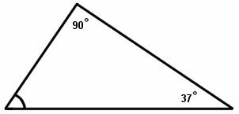

Stem: What is the measure of the missing angle?
Option A.
Option B.
Option C.
Option D.
Option E.
Key: B
RIT Range: 231 Goal 3.7
Copyright Info:
Idaho Content Alignment: 341.01.a
Learning Cont. Goal: Geometry
Learning Cont. Subgoal: Geometric Properties & Terms
Learning Cont. Bullet #: 4
Learning Cont. Page #: 4
Idaho Falls Content Alignment: "None"
Item Entry Complete: Y

Item ID Number: 30003690
Directions:
Passage or Graphic:

  10 feet | 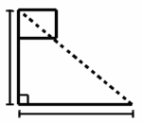
   | 12 feet
  5 feet | 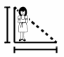
   | x feet

Stem: A flag pole is 10 feet high and casts a shadow 12 feet long. A girl standing nearby is 5 feet tall. What is the length of her shadow?
Option A. 8 feet
Option B. 4 feet
Option C. 6 feet
Option D. 10 feet
Option E. 12 feet
Key: C
RIT Range: 231 Goal 3.7.1
Copyright Info:
Idaho Content Alignment: 339.03.a, 341.01.d
Learning Cont. Goal: Geometry
Learning Cont. Subgoal: Geometric Properties & Terminology
Learning Cont. Bullet #: 5
Learning Cont. Page #: 4
Idaho Falls Content Alignment: "291350"
Item Entry Complete: Y

Item ID Number: 30003700
Directions:
Passage or Graphic:

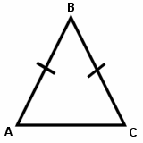

Stem: What are the base angles of ?
Option A. and
Option B. and
Option C. and
Option D. and
Option E. and
Key: B
RIT Range: 231 Goal 3.5.3
Copyright Info:
Idaho Content Alignment: 341.01.a, 341.01.h
Learning Cont. Goal: Geometry
Learning Cont. Subgoal: Geometric Properties & Terminology
Learning Cont. Bullet #: 6
Learning Cont. Page #: 4
Idaho Falls Content Alignment: "291343"
Item Entry Complete: Y

Item ID Number: 30003710
Directions:
Passage or Graphic:

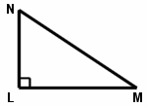

Stem: What name is given to the side opposite the right angle in ?
Option A. acute
Option B. base
Option C. leg
Option D. hypotenuse
Option E. obtuse
Key: D
RIT Range: 231 Goal 3.7.6
Copyright Info:
Idaho Content Alignment: 341.01.h
Learning Cont. Goal: Geometry
Learning Cont. Subgoal: Geometric Properties & Terminology
Learning Cont. Bullet #: 7
Learning Cont. Page #: 4
Idaho Falls Content Alignment: "None"
Item Entry Complete: Y

Item ID Number: 30003720
Directions:
Passage or Graphic:

a) | 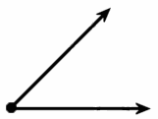 | b) | 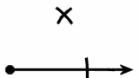

Stem: Using drawing a), what construction does drawing b) illustrate?
Option A. congruent angle
Option B. congruent segment
Option C. congruent triangle
Option D. vertical angle
Option E. supplementary angle
Key: A
RIT Range: 241 Goal 3.13
Copyright Info:
Idaho Content Alignment: 341.01.b
Learning Cont. Goal: Geometry
Learning Cont. Subgoal: Congruency & Similarity
Learning Cont. Bullet #: 1
Learning Cont. Page #: 4
Idaho Falls Content Alignment: "None"
Item Entry Complete: Y

Item ID Number: 30003740
Directions: Complete the statement.
Passage or Graphic:
Stem: Parallel lines are ________.
Option A. in the same plane and do not intersect
Option B. in the same plane and do intersect
Option C. in different planes and do not intersect
Option D. in different planes and do intersect
Option E. in different planes that may intersect
Key: A
RIT Range: 241 Goal 3.2.1
Copyright Info:
Idaho Content Alignment: 31.01.c
Learning Cont. Goal: Geometry
Learning Cont. Subgoal: Geometric Properties & Terminology
Learning Cont. Bullet #: 1
Learning Cont. Page #: 4
Idaho Falls Content Alignment: "None"
Item Entry Complete: N - needs fifth option

Rearrange answers – too many a’s
Item ID Number: 30003750
Directions:
Passage or Graphic:

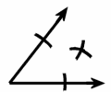

Stem: The drawing illustrates a method for constructing ________.
Option A. a perpendicular bisector
Option B. a supplementary angle
Option C. a right angle
Option D. a segment bisector
Option E. an angle bisector
Key: E
RIT Range: 241 Goal 3.13
Copyright Info:
Idaho Content Alignment: 341.01.b
Learning Cont. Goal: Geometry
Learning Cont. Subgoal: Geometric Properties & Terminology
Learning Cont. Bullet #: 2
Learning Cont. Page #: 4
Idaho Falls Content Alignment: "None"
Item Entry Complete: Y

Item ID Number: 30003760
Directions:
Passage or Graphic:

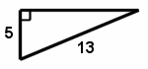

Stem: What is the length of the missing side?
Option A. 12
Option B. 8
Option C. 18
Option D. 16
Option E. 14
Key: A
RIT Range: 241 Goal 3.7.5
Copyright Info:
Idaho Content Alignment: 341.02.a
Learning Cont. Goal: Geometry
Learning Cont. Subgoal: Geometric Properties & Terminology
Learning Cont. Bullet #: 3
Learning Cont. Page #: 4
Idaho Falls Content Alignment: “None”
Item Entry Complete: Y

Too many A’s
Item ID Number: 30003770
Directions:
Passage or Graphic:

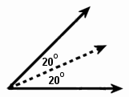

Stem: The dashed line represents ________.
Option A. an altitude
Option B. a perpendicular bisector
Option C. an angle bisector
Option D. a hypotenuse
Option E. a supplementary angle
Key: C
RIT Range: 241 Goal 3.11.11
Copyright Info:
Idaho Content Alignment: 341.01.b
Learning Cont. Goal: Geometry
Learning Cont. Subgoal: Geometric Properties & Terminology
Learning Cont. Bullet #: 4
Learning Cont. Page #: 4
Idaho Falls Content Alignment: "None"
Item Entry Complete: Y

Item ID Number: 30003780
Directions:
Passage or Graphic:

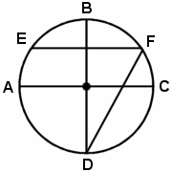

Stem: Which two chords in the diagram have the same length?
Option A. BD and AC
Option B. EF and BD
Option C. EF and AC
Option D. FD and AC
Option E. FD an BD
Key: A
RIT Range: 241 Goal 3.5
Copyright Info:
Idaho Content Alignment: "None"
Learning Cont. Goal: Geometry
Learning Cont. Subgoal: Geometric Properties & Terminology
Learning Cont. Bullet #: 5
Learning Cont. Page #: 4
Idaho Falls Content Alignment: "None"
Item Entry Complete: Y

Item ID Number: 30003790
Directions:
Passage or Graphic:

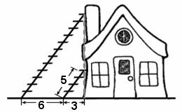

Stem: Two ladders are leaning against a building as shown in the diagram. What is the length of the longer ladder?
Option A.
Option B.
Option C.
Option D.
Option E.
Key: A
RIT Range: 251 Goal 3.7.5
Copyright Info:
Idaho Content Alignment: 341.01.d
Learning Cont. Goal: Geometry
Learning Cont. Subgoal: Congruency & Similarity
Learning Cont. Bullet #: 1
Learning Cont. Page #: 4
Idaho Falls Content Alignment: "None"
Item Entry Complete: Y

Item ID Number: 30003800
Directions:
Passage or Graphic:
Stem: Which of these correctly shows the reflection of the letters 'LS' across the given line?
Option A.
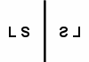
Option B.
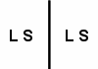
Option C.
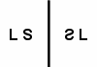
Option D.
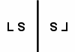
Option E.
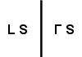
Key: A
RIT Range: 240 Goal 3.3.4
Copyright Info:
Idaho Content Alignment: 341.01.g, 351.01.a
Learning Cont. Goal: Geometry
Learning Cont. Subgoal: Symmetry & Transformations
Learning Cont. Bullet #: 1
Learning Cont. Page #: 4
Idaho Falls Content Alignment: "None"
Item Entry Complete: Y

Item ID Number: 30003810
Directions:
Passage or Graphic:

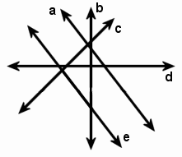

Stem: Which line has positive slope?
Option A. a
Option B. b
Option C. c
Option D. d
Option E. e
Key: C
RIT Range: 251 Goal 3.2.3
Copyright Info:
Idaho Content Alignment: 343.01.b
Learning Cont. Goal: Geometry
Learning Cont. Subgoal: Geometric Properties & Terminology
Learning Cont. Bullet #: 1
Learning Cont. Page #: 4
Idaho Falls Content Alignment: "None"
Item Entry Complete: Y

Item ID Number: 30003820
Directions:
Passage or Graphic:

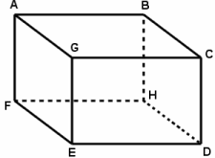

Stem: In the diagram, which of these points define a plane?
Option A. ABCG
Option B. AB
Option C. AFGD
Option D. ED
Option E. FHCD
Key: A
RIT Range: 251 Goal 3.5.3
Copyright Info:
Idaho Content Alignment: 341.01.c
Learning Cont. Goal: Geometry
Learning Cont. Subgoal: Geomentric Properties & Terminology
Learning Cont. Bullet #: 2
Learning Cont. Page #: 4
Idaho Falls Content Alignment: "None"
Item Entry Complete: Y

Item ID Number: 30003830
Directions:
Passage or Graphic:

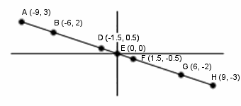

Stem: Which point is the midpoint of line segment ?
Option A. F
Option B. A
Option C. D
Option D. E
Option E. G
Key: A
RIT Range: 251 Goal 3.2.4
Copyright Info:
Idaho Content Alignment: 341.01.c
Learning Cont. Goal: Geometry
Learning Cont. Subgoal: Geometric Properties & Terminology
Learning Cont. Bullet #: 3
Learning Cont. Page #: 4
Idaho Falls Content Alignment: "None"
Item Entry Complete: Y

Too many A’s
Item ID Number: 30003850
Directions:
Passage or Graphic:
Stem: Which property of parallelograms applies only to the rhombus?
Option A. Diagonals bisect each other.
Option B. Opposite angles are congruent.
Option C. Consecutive sides are congruent.
Option D. Consecutive angles are supplementary.
Option E. Diagonals are perpendicular to each other.
Key: E
RIT Range: 251 Goal 3.5
Copyright Info:
Idaho Content Alignment: 341.01.a
Learning Cont. Goal: Geometry
Learning Cont. Subgoal: Geometric Properties & Terminology
Learning Cont. Bullet #: 5
Learning Cont. Page #: 4
Idaho Falls Content Alignment: "None"
Item Entry Complete: Y

Item ID Number: 30003860
Directions:
Passage or Graphic:
Stem: A statement that is used as the basis for a line of reasoning and is assumed to be true but not proven is called a ________.
Option A. postulate
Option B. theorem
Option C. best guess
Option D. hypothesis
Option E. corollary
Key: A
RIT Range: 261 Goal 3.10
Copyright Info:
Idaho Content Alignment: 341.01.h
Learning Cont. Goal: Geometry
Learning Cont. Subgoal: Geometric Properties & Terminology
Learning Cont. Bullet #: 1
Learning Cont. Page #: 5
Idaho Falls Content Alignment: "None"
Item Entry Complete: Y

Item ID Number: 30003870
Directions:
Passage or Graphic:

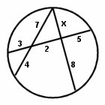

Stem: In the diagram, what is the correct value for x?
Option A.
Option B.
Option C.
Option D.
Option E.
Key: A
RIT Range: 270 Goal 8.4
Copyright Info:
Idaho Content Alignment: 341.01.c
Learning Cont. Goal: Geometry
Learning Cont. Subgoal: Geometric Properties & Terminology
Learning Cont. Bullet #: 2
Learning Cont. Page #: 5
Idaho Falls Content Alignment: "None"
Item Entry Complete: Y

Item ID Number: 30003890
Directions:
Passage or Graphic:
Stem: What is the correct classification for the triangle formed by the points P(4, 4), Q(1, 0) and R(8, 1)?
Option A. scalene
Option B. obtuse
Option C. acute
Option D. equilateral
Option E. isosceles
Key: A
RIT Range: 261 Goal 3.7.3.1
Copyright Info:
Idaho Content Alignment: 341.01.a
Learning Cont. Goal: Geometry
Learning Cont. Subgoal: Geometric Properties & Terminology
Learning Cont. Bullet #: 4
Learning Cont. Page #: 5
Idaho Falls Content Alignment: "None"
Item Entry Complete: Y

Item ID Number: 30003900
Directions:
Passage or Graphic:

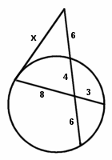

Stem: In the diagram, what is the correct value for x?
Option A. 9.8
Option B. 4.9
Option C. 7.7
Option D. 8.1
Option E. 12.0
Key: A
RIT Range: 270 Goal 4.4.6
Copyright Info:
Idaho Content Alignment: 341.01.c
Learning Cont. Goal: Geometry
Learning Cont. Subgoal: Geometric Properties & Terminology
Learning Cont. Bullet #: 5
Learning Cont. Page #: 5
Idaho Falls Content Alignment: "None"
Item Entry Complete: Y

Item ID Number: 30003910
Directions:
Passage or Graphic:

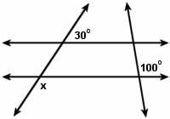

Stem: In the diagram, what is the correct value for x?
Option A.
Option B.
Option C.
Option D.
Option E.
Key: A
RIT Range: 261 Goal 3.11.3
Copyright Info:
Idaho Content Alignment: 341.01.c
Learning Cont. Goal: Geometry
Learning Cont. Subgoal: Geometric Properties & Terminology
Learning Cont. Bullet #: 6
Learning Cont. Page #: 5
Idaho Falls Content Alignment: "None"
Item Entry Complete: Y

Item ID Number: 30003920
Directions:
Passage or Graphic:

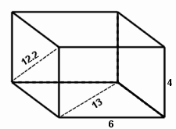

Stem: What is the volume of this rectangular prism?
Option A. 276.0
Option B. 312.0
Option C. 561.2
Option D. 841.8
Option E. 278.0
Key: A
RIT Range: 270 Goal 8.4
Copyright Info:
Idaho Content Alignment: 341.01.f
Learning Cont. Goal: Geometry
Learning Cont. Subgoal: Geometric Properties & Terminology
Learning Cont. Bullet #: 7
Learning Cont. Page #: 5
Idaho Falls Content Alignment: "None"
Item Entry Complete: Y

Item ID Number: 30003930
Directions:
Passage or Graphic:
Stem: The diameter of sphere A is twice the size of sphere B. What is the ratio of the volume of sphere A to that of sphere B?
Option A. 8:1
Option B. 1:8
Option C. 2:1
Option D. 1:2
Option E. 1:1
Key: A
RIT Range: 270 Goal 8.5
Copyright Info:
Idaho Content Alignment: 341.01.f, 351.01.b
Learning Cont. Goal: Geometry
Learning Cont. Subgoal: Geometric Properties & Terminology
Learning Cont. Bullet #: 8
Learning Cont. Page #: 5
Idaho Falls Content Alignment: “None”
Item Entry Complete: Y

Item ID Number: 30003940
Directions:
Passage or Graphic:
Stem: A swimming pool in the shape of a regular polygon has an exterior angle with measure . What is the shape of the pool?
Option A. octagon
Option B. pentagon
Option C. hexagon
Option D. square
Option E. triangle
Key: A
RIT Range: 270 Goal 8.4
Copyright Info:
Idaho Content Alignment: 341.01.a
Learning Cont. Goal: Geometry
Learning Cont. Subgoal: Geometric Properties & Terminology
Learning Cont. Bullet #: 9
Learning Cont. Page #: 5
Idaho Falls Content Alignment: "None"
Item Entry Complete: Y

Item ID Number: 30003950
Directions:
Passage or Graphic:
Stem: Given the figure formed by the points (1, -3), (4, -5) and (6, -2), what are the vertices of the figure formed when reflected across both the x and y axes?
Option A. (-1, 3), (-4, 5) and (-6, 2)
Option B. (-1, -3), (-4, -5) and (-6, -2)
Option C. (1, 3), (4, 5) and (6, 2)
Option D. (-3, 1), (-5, 4) and (-2, 6)
Option E. (3, -1), (5, -4) and (2, -6)
Key: A
RIT Range: 270 Goal 3.3.4
Copyright Info:
Idaho Content Alignment: 341.01.g, 351.01.a, 351.03.a
Learning Cont. Goal: Geometry
Learning Cont. Subgoal: Geometric Properties & Terminology
Learning Cont. Bullet #: 10
Learning Cont. Page #: 5
Idaho Falls Content Alignment: "None"
Item Entry Complete: Y

Item ID Number: 30003960
Directions:
Passage or Graphic:

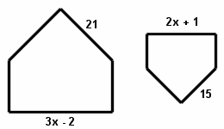

Stem: What value of x would make these pentagons similar?
Option A. 17
Option B. 11
Option C. 19
Option D. 3
Option E. 10
Key: A
RIT Range: 280 Goal 8.4
Copyright Info:
Idaho Content Alignment: 341.01.d, 351.01.b
Learning Cont. Goal: Geometry
Learning Cont. Subgoal: Congruence & Similarity
Learning Cont. Bullet #: 1
Learning Cont. Page #: 5
Idaho Falls Content Alignment: "None"
Item Entry Complete: Y

Item ID Number: 30003970
Directions:
Passage or Graphic:
Stem: How many diagonals are there in an octagon?
Option A. 20
Option B. 16
Option C. 14
Option D. 27
Option E. 24
Key: A
RIT Range: 271 Goal 3.5
Copyright Info:
Idaho Content Alignment: 341.01.a
Learning Cont. Goal: Geometry
Learning Cont. Subgoal: Geometric Properties & Terminology
Learning Cont. Bullet #: 1
Learning Cont. Page #: 5
Idaho Falls Content Alignment: "None"
Item Entry Complete: Y

Item ID Number: 30003980
Directions:
Passage or Graphic:

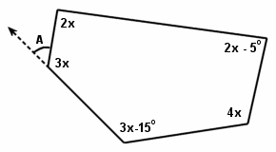

Stem: What is the measure of angle A?
Option A.
Option B.
Option C.
Option D.
Option E.
Key: A
RIT Range: 280 Goal 8.4
Copyright Info:
Idaho Content Alignment: 341.01.c
Learning Cont. Goal: Geometry
Learning Cont. Subgoal: Geometric Properties & Terminology
Learning Cont. Bullet #: 2
Learning Cont. Page #: 5
Idaho Falls Content Alignment: "None"
Item Entry Complete: Y

Item ID Number: 30003990
Directions:
Passage or Graphic:
Stem: What is the volume of the three-dimensional figure formed by rotating an equilateral triangle with a side of 4 units about one of its altitudes?
Option A.
Option B.
Option C.
Option D.
Option E.
Key: A
RIT Range: 290 Goal 8.5
Copyright Info:
Idaho Content Alignment: 341.01.f, 341.01.g
Learning Cont. Goal: Geometry
Learning Cont. Subgoal: Symmetry & Transformation
Learning Cont. Bullet #: 1
Learning Cont. Page #: 5
Idaho Falls Content Alignment: "None"
Item Entry Complete: Y

