Item ID Number: 30004000
Directions:
Passage or Graphic:
1
2
3
4
5

Stem: Which tree is the tallest?
Option A. 1
Option B. 2
Option C. 3
Option D. 4
Option E. 5
Key: D
RIT Range: 151 Goal 4.1
Copyright Info:
Idaho Content Alignment: “none”
Learning Cont. Goal: Measurement
Learning Cont. Subgoal: Length, Height, Volume
Learning Cont. Bullet #: 1
Learning Cont. Page #: 1
Idaho Falls Content Alignment: “none”
Item Entry Complete: y

Item ID Number: 30004010
Directions:
Passage or Graphic:
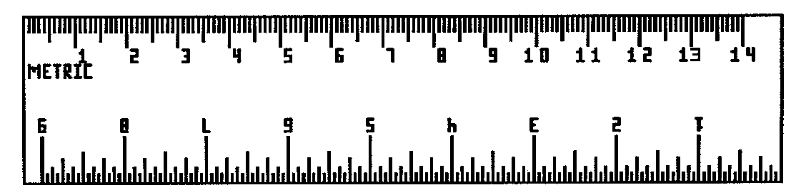

Stem: How long is the pencil?
Option A. 7 cm.
Option B. 6 cm.
Option C. 4 cm.
Option D. 5 cm.
Option E. 3 cm.
Key: D
RIT Range: 160 4.1.4
Copyright Info:
Idaho Content Alignment: 299.01.a
Learning Cont. Goal: Measurement
Learning Cont. Subgoal: Length, Height, Volume
Learning Cont. Bullet #: 2
Learning Cont. Page #: 1
Idaho Falls Content Alignment: “Abacus 90-2”
Item Entry Complete: Y

Item ID Number: 30004020
Directions:
Passage or Graphic: 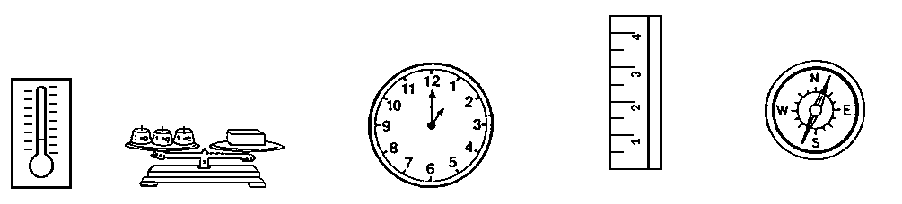
A B C D E
Stem: Which would you use to tell time?
Option A. A
Option B. B
Option C. C
Option D. D
Option E. E
Key: C
RIT Range: 160 4.6.2
Copyright Info:
Idaho Content Alignment: 299.01.a
Learning Cont. Goal: Measurement
Learning Cont. Subgoal: Time, Temperature
Learning Cont. Bullet #: 1
Learning Cont. Page #: 1
Idaho Falls Content Alignment: “None”
Item Entry Complete: Y

Item ID Number: 30004030
Directions:
Passage or Graphic: 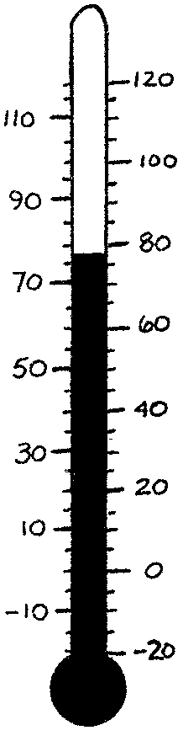
Stem: What is the temperature?
Option A. 30º F
Option B. 100º F
Option C. 55º F
Option D. 78º F
Option E. 89º F
Key: D
RIT Range: 160 Goal 4.8.3
Copyright Info:
Idaho Content Alignment: 299.01.a
Learning Cont. Goal: Measurement
Learning Cont. Subgoal: Time, Temperature
Learning Cont. Bullet #: 2
Learning Cont. Page #: 1
Idaho Falls Content Alignment: “Abacus 102-2”
Item Entry Complete: Y

Item ID Number: 30004040
Directions:
Passage or Graphic: January, February, _________
Stem: Which month comes next?
Option A. October
Option B. December
Option C. September
Option D. March
Option E. April
Key: D
RIT Range: 161 4.6.3
Copyright Info:
Idaho Content Alignment: 299.01.a
Learning Cont. Goal: Measurement
Learning Cont. Subgoal: Time, Temperature
Learning Cont. Bullet #: 1
Learning Cont. Page #: 1
Idaho Falls Content Alignment: “None”
Item Entry Complete: Y

Item ID Number: 30004050
Directions:
Passage or Graphic: 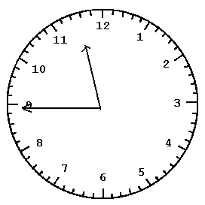
Stem: What time is it?
Option A. 8:58
Option B. 12:09
Option C. 11:44
Option D. 10:15
Option E. 5:23
Key: C
RIT Range: 170 4.6.2
Copyright Info:
Idaho Content Alignment: 279.02.a
Learning Cont. Goal: Measurement
Learning Cont. Subgoal: Time, Temperature
Learning Cont. Bullet #: 2
Learning Cont. Page #: 1
Idaho Falls Content Alignment: “Abacus99-2”
Item Entry Complete: Y

Item ID Number: 300004060
Directions:
Passage or Graphic: 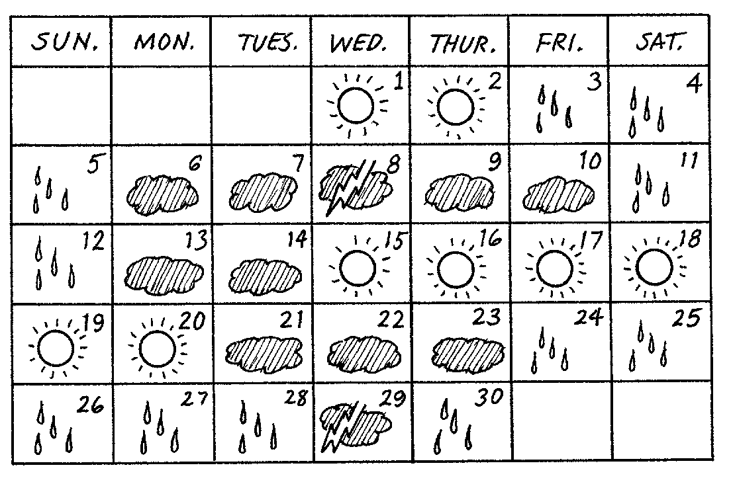
Stem: What day of the week is the 1st?
Option A. Friday
Option B. Sunday
Option C. Tuesday
Option D. Wednesday
Option E. Saturday
Key: D
RIT Range: 161 4.6.3
Copyright Info:
Idaho Content Alignment: 279.01.a
Learning Cont. Goal: Measurement
Learning Cont. Subgoal: Time, Temperature
Learning Cont. Bullet #: 3
Learning Cont. Page #: 1
Idaho Falls Content Alignment: “Abacus 98-2”
Item Entry Complete: Y

Item ID Number: 30004070
Directions:
Passage or Graphic: 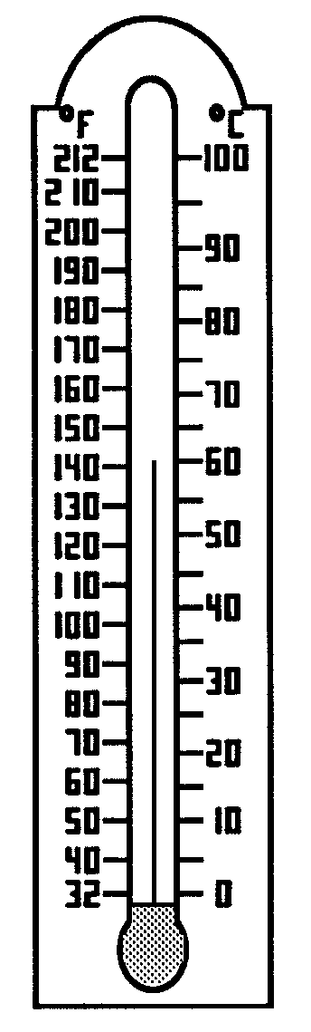
Stem: What is the temperature in degrees Celsius?
Option A. 80º C
Option B. 140º C
Option C. 50º C
Option D. 60º C
Option E. 20º C
Key: D
RIT Range: 161 4.8.4
Copyright Info:
Idaho Content Alignment: 299.01.a
Learning Cont. Goal: Measurement
Learning Cont. Subgoal: Time, Temperature
Learning Cont. Bullet #: 4
Learning Cont. Page #: 1
Idaho Falls Content Alignment: “Abacus102-2”
Item Entry Complete: Y

Item ID Number: 30004080
Directions:
Passage or Graphic: 
Stem: How much is this coin worth?
Option A. 5¢
Option B. 10¢
Option C. 1¢
Option D. 50¢
Option E. 25¢
Key: E
RIT Range: 161 4.7
Copyright Info:
Idaho Content Alignment: 299.01.a
Learning Cont. Goal: Measurement
Learning Cont. Subgoal: Money
Learning Cont. Bullet #: 1
Learning Cont. Page #: 1
Idaho Falls Content Alignment: “Abacus34/108-1/2”
Item Entry Complete: Y

Item ID Number: 30004090
Directions:
Passage or Graphic: 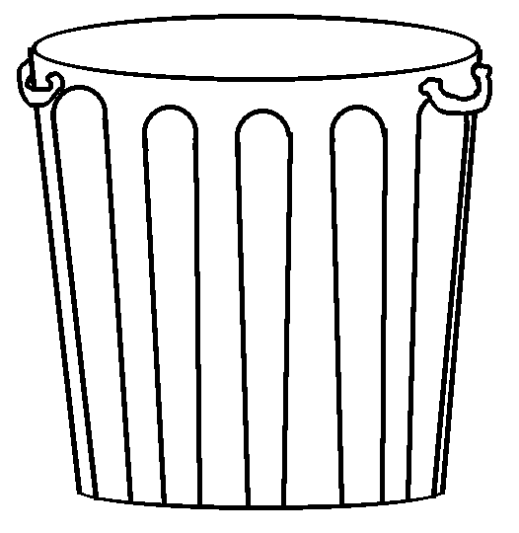 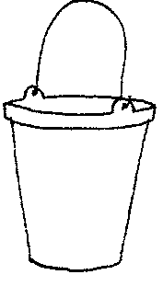 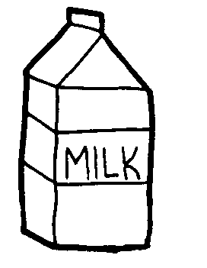 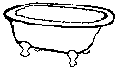 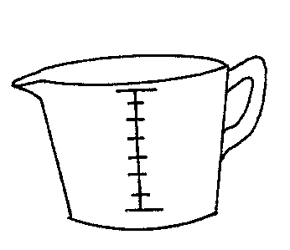
A B C D E

Stem: Which holds the most?
Option A. A
Option B. B
Option C. C
Option D. D
Option E. E
Key: D
RIT Range: 180 4.10
Copyright Info:
Idaho Content Alignment: 299.01.a
Learning Cont. Goal: Measurement
Learning Cont. Subgoal: Length, Weight, Volume
Learning Cont. Bullet #: 1
Learning Cont. Page #: 1
Idaho Falls Content Alignment: “None”
Item Entry Complete: Y

Item ID Number: 30004100
Directions:
Passage or Graphic: 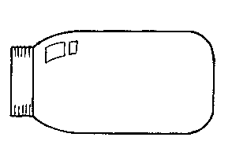

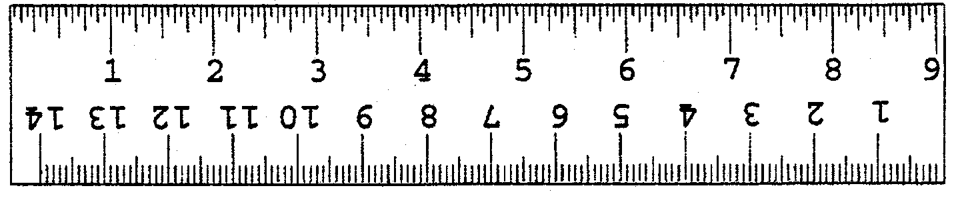
Stem: How long is the light bulb?
Option A. 4 inches
Option B. 3 inches
Option C. 2 inches
Option D. 1 inch
Option E. 5 inches
Key: A
RIT Range: 171 4.1.2
Copyright Info:
Idaho Content Alignment: 279.01.a
Learning Cont. Goal: Measurement
Learning Cont. Subgoal: Length, Weight, Volume
Learning Cont. Bullet #: 2
Learning Cont. Page #: 1
Idaho Falls Content Alignment: “Abacus30/90-1/2”
Item Entry Complete: Y

Item ID Number: 30004110
Directions:
Passage or Graphic: 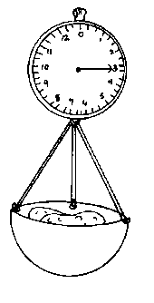
Stem: How much do the potatoes weigh?
Option A. 9 lbs.
Option B. 6 lbs.
Option C. 3 lbs.
Option D. 0 lbs.
Option E. 4 lbs.
Key: C
RIT Range: 180 4.9.2
Copyright Info:
Idaho Content Alignment: 279.01.a
Learning Cont. Goal: Measurement
Learning Cont. Subgoal: Length, Weight, Volume
Learning Cont. Bullet #: 3
Learning Cont. Page #: 1
Idaho Falls Content Alignment: “None”
Item Entry Complete: Y

Item ID Number: 30004120
Directions:
Passage or Graphic:

1 cup 1 cup 1 cup 1 cup
Stem: This is the same as:
Option A. 1 pint
Option B. 1 gallon
Option C. 1 quart
Option D. 2 quarts
Option E. 3 pints
Key: C
RIT Range: 180 Goal 4.10.2
Copyright Info:
Idaho Content Alignment: 299.01.a
Learning Cont. Goal: Measurement
Learning Cont. Subgoal: Length, Weight, Volume
Learning Cont. Bullet #: 4
Learning Cont. Page #: 1
Idaho Falls Content Alignment: “Abacus 146-4”
Item Entry Complete: Y

Item ID Number: 30004130
Directions:
Passage or Graphic:

Stem: The pencil is about how many centimeters long?
Option A. 5 cm.
Option B. 6 cm.
Option C. 7 cm.
Option D. 4 cm.
Option E. 8 cm.
Key: C
RIT Range: 180 4.1.6
Copyright Info:
Idaho Content Alignment: 279.01.a
Learning Cont. Goal: Measurement
Learning Cont. Subgoal: Length, Weight, Volume
Learning Cont. Bullet #: 5
Learning Cont. Page #: 1
Idaho Falls Content Alignment: “Abacus 114-3”
Item Entry Complete: Y

Item ID Number: 30004140
Directions:
Passage or Graphic:
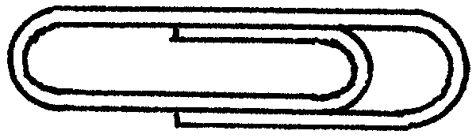
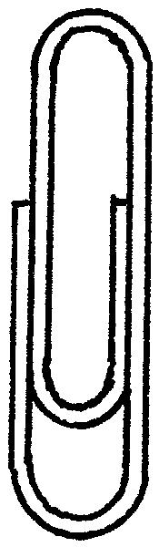

Stem: How about how many paper clips would be needed to go around this shape?
Option A. 6
Option B. 14
Option C. 10
Option D. 12
Option E. 13
Key: D
RIT Range: 180 Goal 4.5.1
Copyright Info:
Idaho Content Alignment: 279.01.a
Learning Cont. Goal: Measurement
Learning Cont. Subgoal: Area, Perimeter, Circumference
Learning Cont. Bullet #: 1
Learning Cont. Page #: 1
Idaho Falls Content Alignment: “Abacus 135-4”
Item Entry Complete: Y

Item ID Number: 30004150
Directions: Find the area in square units.
Passage or Graphic:
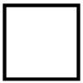

= 1 square unit
Stem:
Option A. 18
Option B. 16
Option C. 20
Option D. 12
Option E. 24
Key: A
RIT Range: 180 4.3.4
Copyright Info:
Idaho Content Alignment: 299.01.a
Learning Cont. Goal: Measurement
Learning Cont. Subgoal: Area, Perimeter, Circumference
Learning Cont. Bullet #: 2
Learning Cont. Page #: 1
Idaho Falls Content Alignment: “Abacus 136-4”
Item Entry Complete: Y

Item ID Number: 30004160
Directions: Read the time.
Passage or Graphic: 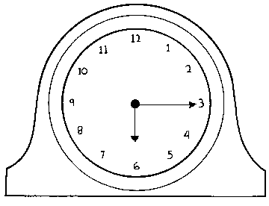
Stem:
Option A. 3:30
Option B. 6:45
Option C. 6:15
Option D. 5:15
Option E. 3:06
Key: C
RIT Range: 180 4.6.2
Copyright Info:
Idaho Content Alignment: 299.01.e
Learning Cont. Goal: Measurement
Learning Cont. Subgoal: Time, Temperature
Learning Cont. Bullet #: 1
Learning Cont. Page #: 1
Idaho Falls Content Alignment: “Abacus 99/100-2”
Item Entry Complete: Y

Item ID Number: 30004170
Directions:
Passage or Graphic: 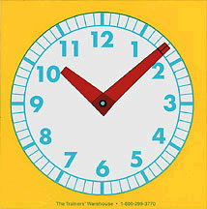
Stem: What time is it?
Option A. 10:08
Option B. 10:02
Option C. 1:52
Option D. 1:10
Option E. 11:08
Key: A
RIT Range: 180 4.6.2
Copyright Info:
Idaho Content Alignment: 299.01.e
Learning Cont. Goal: Measurement
Learning Cont. Subgoal: Time, Temperature
Learning Cont. Bullet #: 2
Learning Cont. Page #: 2
Idaho Falls Content Alignment: “District 122, grade 3”
Item Entry Complete: Y

Item ID Number: 30004180
Directions:
Passage or Graphic:
7 days in one week
Stem: How many days in three weeks?
Option A. 10
Option B. 21
Option C. 7
Option D. 4
Option E. 3
Key: B
RIT Range: 180 4.6.3
Copyright Info:
Idaho Content Alignment: 299.01.f/279.01.a
Learning Cont. Goal: Measurement
Learning Cont. Subgoal: Time, Temperature
Learning Cont. Bullet #: 3
Learning Cont. Page #: 2
Idaho Falls Content Alignment: “District 127, grade 4”
Item Entry Complete: Y

Item ID Number: 30004190
Directions:
Passage or Graphic: 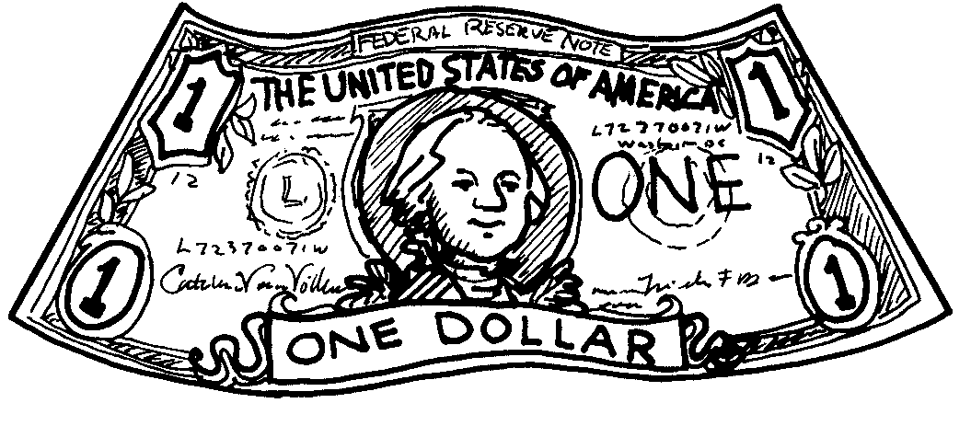
Stem: The value of the money is:
Option A. $2.00
Option B. $1.00
Option C. $3.00
Option D. $4.00
Option E. $30.00
Key: C
RIT Range: 180 4.7
Copyright Info:
Idaho Content Alignment: 297.01.c
Learning Cont. Goal: Measurement
Learning Cont. Subgoal: Money
Learning Cont. Bullet #: 1
Learning Cont. Page #: 2
Idaho Falls Content Alignment: “District 131/130, grade3/4”
Item Entry Complete: Y

Item ID Number: 30004210
Directions:
Passage or Graphic:

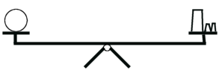
ball 5g, 1g, 1g weights

Stem: The ball weighs:
Option A. 5g
Option B. 2g
Option C. 1g
Option D. 6g
Option E. 7g
Key: E
RIT Range: 190 4.9.4
Copyright Info:
Idaho Content Alignment: 279.01.a/299.01.a
Learning Cont. Goal: Measurement
Learning Cont. Subgoal: Length, Weight, Volume
Learning Cont. Bullet #: 1
Learning Cont. Page #: 2
Idaho Falls Content Alignment: “District #65, grade 6”
Item Entry Complete: Y

Item ID Number: 30004220
Directions:
Passage or Graphic:
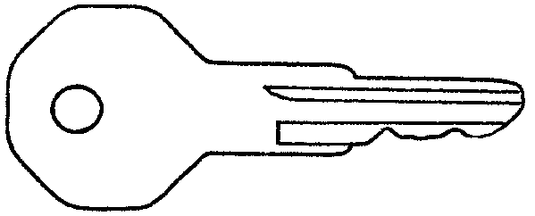
Stem: How long is the key?
Option A. 3 in.
Option B. 4 in.
Option C. 2 in.
Option D. 5 in.
Option E. 1 in.
Key: A
RIT Range: 190 4.1.2
Copyright Info:
Idaho Content Alignment: 299.01.a
Learning Cont. Goal: Measurement
Learning Cont. Subgoal: Length, Weight, Volume
Learning Cont. Bullet #: 2
Learning Cont. Page #: 2
Idaho Falls Content Alignment: “District #114/117, grade 3/4"
Item Entry Complete: Y

Item ID Number: 30004230
Directions:
Passage or Graphic:
= 1 square unit
Stem: How many square units?
Option A. 10
Option B. 11
Option C. 9
Option D. 12
Option E. 12
Key: B
RIT Range: 181 4.3.4
Copyright Info:
Idaho Content Alignment: 299.01.a
Learning Cont. Goal: Measurement
Learning Cont. Subgoal: Area, Perimeter, Circumference
Learning Cont. Bullet #: 1
Learning Cont. Page #: 2
Idaho Falls Content Alignment: “District #136, grade 4”
Item Entry Complete: Y

Item ID Number: 30004240
Directions:

Passage or Graphic:
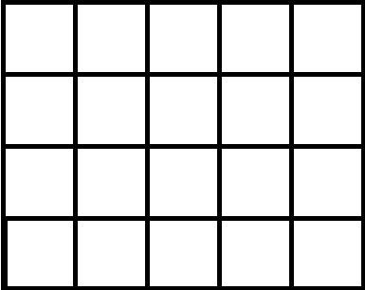

Stem: What is the area of the figure?
Option A. 18 square units
Option B. 9 square units
Option C. 20 square units
Option D. 16 square units
Option E. 5 square units
Key: C
RIT Range: 190 4.3.3
Copyright Info:
Idaho Content Alignment: 299.01.a
Learning Cont. Goal: Measurement
Learning Cont. Subgoal: Area, Perimeter, Circumference
Learning Cont. Bullet #: 2
Learning Cont. Page #: 2
Idaho Falls Content Alignment: “District #136, grade 4”
Item Entry Complete: Y

Item ID Number: 30004250
Directions:

Passage or Graphic:
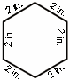
Stem: What is the perimeter of the above shape?
Option A. 2 inches
Option B. 8 inches
Option C. 10 inches
Option D. 12 inches
Option E. 6 inches
Key: D
RIT Range: 190 4.5.2
Copyright Info:
Idaho Content Alignment: 299.01.a
Learning Cont. Goal: Measurement
Learning Cont. Subgoal: Area, Perimeter, Circumference
Learning Cont. Bullet #: 3
Learning Cont. Page #: 2
Idaho Falls Content Alignment: “District #137/135, grade 3/4"
Item Entry Complete: Y

Item ID Number: 30004260
Directions:
Passage or Graphic: 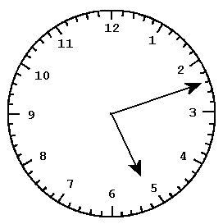
Stem: What time is it?
Option A. 5:10
Option B. 4:12
Option C. 2:28
Option D. 6:13
Option E. 5:12
Key: E
RIT Range: 181 4.6.2
Copyright Info:
Idaho Content Alignment: 299.01.e
Learning Cont. Goal: Measurement
Learning Cont. Subgoal: Time, Temperature
Learning Cont. Bullet #: 1
Learning Cont. Page #: 2
Idaho Falls Content Alignment: “District #122, grade 3”
Item Entry Complete: Y

Item ID Number: 30004270
Directions:
Passage or Graphic:
Stem: 6 p.m. is:
Option A. 4 hours after 2 p.m.
Option B. 4 hours after 10 p.m.
Option C. 6 hours before noon.
Option D. 6 hours after midnight.
Option E. 4 hours before midnight.
Key: A
RIT Range: 190 4.6.1
Copyright Info:
Idaho Content Alignment: 299.01.f
Learning Cont. Goal: Measurement
Learning Cont. Subgoal: Time, Temperature
Learning Cont. Bullet #: 2
Learning Cont. Page #: 2
Idaho Falls Content Alignment: “None”
Item Entry Complete: Y

Item ID Number: 30004280
Directions:
Passage or Graphic:
Stem: 30 minutes after 5:15 is:
Option A. 5:18
Option B. 5:45
Option C. 4:45
Option D. 6:15
Option E. 5:15
Key: B
RIT Range: 181 4.6.1
Copyright Info:
Idaho Content Alignment: 299.01.f
Learning Cont. Goal: Measurement
Learning Cont. Subgoal: Time, Temperature
Learning Cont. Bullet #: 3
Learning Cont. Page #: 2
Idaho Falls Content Alignment: “District #127, grade 4”
Item Entry Complete: Y

Item ID Number: 30004290
Directions:
Passage or Graphic: 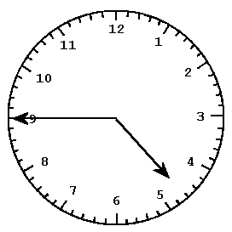
Stem: What time is 25 minutes later than the time shown on the clock?
Option A. 5:15
Option B. 4:10
Option C. 5:10
Option D. 4:45
Option E. 5:05
Key: C
RIT Range: 190 4.6.1
Copyright Info:
Idaho Content Alignment: 299.01.f
Learning Cont. Goal: Measurement
Learning Cont. Subgoal: Time, Temperature
Learning Cont. Bullet #: 4
Learning Cont. Page #: 2
Idaho Falls Content Alignment: “District #127, grade 4”
Item Entry Complete: Y

Item ID Number: 30004310
Directions:
Passage or Graphic: 
Stem: What is the value of this coin?
Option A. 1¢
Option B. 5¢
Option C. 25¢
Option D. 50¢
Option E. 10¢
Key: E
RIT Range: 190 4.7
Copyright Info:
Idaho Content Alignment: 297.01.c
Learning Cont. Goal: Measurement
Learning Cont. Subgoal: Money
Learning Cont. Bullet #: 2
Learning Cont. Page #: 2
Idaho Falls Content Alignment: “District #33, grade 1”
Item Entry Complete: Y

Item ID Number: 30004320
Directions:
Passage or Graphic:
Stem: 3 dollars, 1 quarter, and 1 dime equal:
Option A. $3.35
Option B. $1.35
Option C. $2.35
Option D. $3.25
Option E. $3.10
Key: A
RIT Range: 190 4.7
Copyright Info:
Idaho Content Alignment: 297.01.c
Learning Cont. Goal: Measurement
Learning Cont. Subgoal: Money
Learning Cont. Bullet #: 3
Learning Cont. Page #: 2
Idaho Falls Content Alignment: “District 131, grade 3”
Item Entry Complete: Y

Item ID Number: 30004350
Directions: Solve the problem below.
Passage or Graphic:
$7.83
- $4.95

Stem:
Option A. $3.12
Option B. $3.88
Option C. $12.78
Option D. $2.88
Option E. $2.28
Key: D
RIT Range: 190 1.3.7
Copyright Info:
Idaho Content Alignment: 297.02.d
Learning Cont. Goal: Measurement
Learning Cont. Subgoal: Money
Learning Cont. Bullet #: 6
Learning Cont. Page #: 2
Idaho Falls Content Alignment: “District #28/29, grade 4”
Item Entry Complete: Y

Item ID Number: 30004360
Directions:
Passage or Graphic:

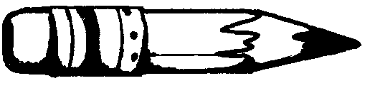

Stem: How long is the pencil?
Option A. 45 cm.
Option B. 40 mm.
Option C. 450 mm.
Option D. 13 cm.
Option E. 45 mm.
Key: E
RIT Range: 200 4.1.4
Copyright Info:
Idaho Content Alignment: 299.01.a
Learning Cont. Goal: Measurement
Learning Cont. Subgoal: Length, Weight, Volume
Learning Cont. Bullet #: 1
Learning Cont. Page #: 2
Idaho Falls Content Alignment: “District #117/67, grade 4/5”
Item Entry Complete: Y

Item ID Number: 30004370
Directions:
Passage or Graphic:
Stem: Which of the following units would be best to use for measuring a classroom?
Option A. meters
Option B. centimeters
Option C. liters
Option D. kilometers
Option E. millimeters
Key: A
RIT Range: 200 Goal 4.1.4
Copyright Info:
Idaho Content Alignment: 299.01.a
Learning Cont. Goal: Measurement
Learning Cont. Subgoal: Length, Weight, Volume
Learning Cont. Bullet #: 2
Learning Cont. Page #: 2
Idaho Falls Content Alignment: “District #142, grade 4”
Item Entry Complete: Y

Item ID Number: 30004380
Directions:
Passage or Graphic:
Stem: 17 inches is equal to:
Option A. 2 feet
Option B. 1 foot, 7 inches
Option C. 1 foot, 5 inches
Option D. 17 feet
Option E. 12 feet, 5 inches
Key: C
RIT Range: 200 4.1.5
Copyright Info:
Idaho Content Alignment: 339.01.a/349.01.a
Learning Cont. Goal: Measurement
Learning Cont. Subgoal: Length, Weight, Volume
Learning Cont. Bullet #: 3
Learning Cont. Page #: 3
Idaho Falls Content Alignment: “District #67, grade 5”
Item Entry Complete: Y

Item ID Number: 30004390
Directions:
Passage or Graphic: 2 pints = 1 quart
Stem: 4 quarts is equal to:
Option A. 4 pints
Option B. 8 pints
Option C. 16 pints
Option D. 2 pints
Option E. 1 pint
Key: B
RIT Range: 200 4.10.2
Copyright Info:
Idaho Content Alignment: 339.01.a
Learning Cont. Goal: Measurement
Learning Cont. Subgoal: Length, Weight, Volume
Learning Cont. Bullet #: 4
Learning Cont. Page #: 3
Idaho Falls Content Alignment: “None”
Item Entry Complete: Y

Item ID Number: 30004400
Directions:
Passage or Graphic:
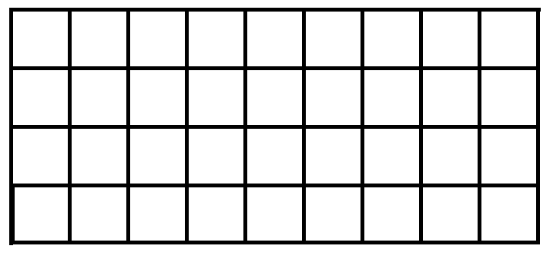 = 1 square meter

Stem: What is the area of the rectangle in square meters?
Option A. 9
Option B. 32
Option C. 36
Option D. 13
Option E. 50
Key: C
RIT Range: 200 4.3.3
Copyright Info:
Idaho Content Alignment: “None”
Learning Cont. Goal: Measurement
Learning Cont. Subgoal: Area, Perimeter, Circumference
Learning Cont. Bullet #: 1
Learning Cont. Page #: 3
Idaho Falls Content Alignment: “District #136/65, grade 4/6”
Item Entry Complete: Y

Item ID Number: 30004410
Directions:
Passage or Graphic:
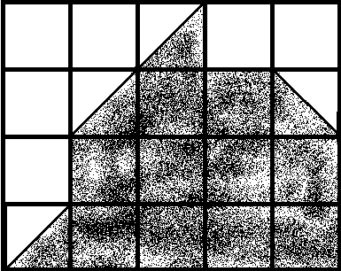 = square unit

Stem: What is the area of the shaded shape, in square units?
Option A. 12
Option B. 10
Option C. 14
Option D. 30
Option E. 16
Key: A
RIT Range: 200 4.3.4
Copyright Info:
Idaho Content Alignment: 339.01.d
Learning Cont. Goal: Measurement
Learning Cont. Subgoal: Area, Perimeter, Circumference
Learning Cont. Bullet #: 2
Learning Cont. Page #: 3
Idaho Falls Content Alignment: “District #?, grade 7”
Item Entry Complete: Y

Item ID Number: 30004420
Directions:
Passage or Graphic:
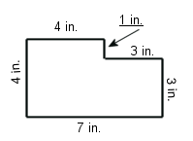
Stem: What is the perimeter of the shape above?
Option A. 11 inches
Option B. 16 inches
Option C. 14 inches
Option D. 21 inches
Option E. 22 inches
Key: E
RIT Range: 200 4.5.3
Copyright Info:
Idaho Content Alignment: 339.01.d
Learning Cont. Goal: Measurement
Learning Cont. Subgoal: Area, Perimeter, Circumference
Learning Cont. Bullet #: 3
Learning Cont. Page #: 3
Idaho Falls Content Alignment: “District #68, grade 5”
Item Entry Complete: Y

Item ID Number: 30004430
Directions:
Passage or Graphic:
Stem: How many minutes are there in 2 hours?
Option A. 60
Option B. 120
Option C. 20
Option D. 100
Option E. 200
Key: B
RIT Range: 200 4.6.1
Copyright Info:
Idaho Content Alignment: “None”
Learning Cont. Goal: Measurement
Learning Cont. Subgoal: Time, Temperature
Learning Cont. Bullet #: 1
Learning Cont. Page #: 3
Idaho Falls Content Alignment: “None”
Item Entry Complete: Y

Item ID Number: 30004440
Directions:
Passage or Graphic:
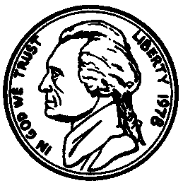
Stem: How much money is pictured?
Option A. $3.68
Option B. $3.75
Option C. $10.68
Option D. $2.68
Option E. $2.00
Key: D
RIT Range: 200 4.7
Copyright Info:
Idaho Content Alignment: “None”
Learning Cont. Goal: Measurement
Learning Cont. Subgoal: Money
Learning Cont. Bullet #: 1
Learning Cont. Page #: 3
Idaho Falls Content Alignment: “District #130, grade 4”
Item Entry Complete: Y

Item ID Number: 30004450
Directions:
Passage or Graphic:
Stem: If Juan has $5.40 and spends $3.10, how much money does he have left?
Option A. $3.10
Option B. $2.30
Option C. $5.40
Option D. $230
Option E. $8.50
Key: B
RIT Range: 200 4.7.1
Copyright Info:
Idaho Content Alignment: 337.02.a
Learning Cont. Goal: Measurement
Learning Cont. Subgoal: Money
Learning Cont. Bullet #: 2
Learning Cont. Page #: 3
Idaho Falls Content Alignment: “District #130, grade 4”
Item Entry Complete: Y

Item ID Number: 30004480
Directions:
Passage or Graphic:
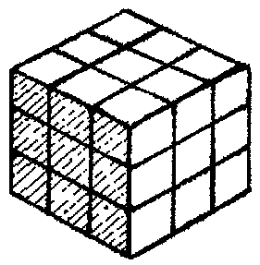 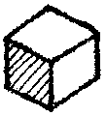 = 1 cubic cm.

Stem: The volume of the cube is ______ cubic centimeters.
Option A. 9
Option B. 6
Option C. 24
Option D. 27
Option E. 1
Key: D
RIT Range: 210 4.10.4
Copyright Info:
Idaho Content Alignment: 339.01.d/349.01.a
Learning Cont. Goal: Measurement
Learning Cont. Subgoal: Length, Weight, Volume
Learning Cont. Bullet #: 1
Learning Cont. Page #: 3
Idaho Falls Content Alignment: “District #?, grade 7”
Item Entry Complete: Y

Item ID Number: 30004490
Directions:
Passage or Graphic: 1,000 g = 1 kg.
Stem: 947 g + 1,053 g =
Option A. 1990 g
Option B. 894 g
Option C. 1,000 g
Option D. 10 kg
Option E. 2 kg
Key: E
RIT Range: 210 4.9.4
Copyright Info:
Idaho Content Alignment: 339.01.d
Learning Cont. Goal: Measurement
Learning Cont. Subgoal: Length, Weight, Volume
Learning Cont. Bullet #: 2
Learning Cont. Page #: 3
Idaho Falls Content Alignment: “District #?, grade 7”
Item Entry Complete: Y

Item ID Number: 30004500
Directions:
Passage or Graphic:
Stem: Which unit of measure would be best for measuring the area of a soccer field?
Option A. meters
Option B. centimeters
Option C. quarts
Option D. inches
Option E. grams
Key: A
RIT Range: 210 4.3.1
Copyright Info:
Idaho Content Alignment: 339.01.b
Learning Cont. Goal: Measurement
Learning Cont. Subgoal: Length, Weight, Volume
Learning Cont. Bullet #: 3
Learning Cont. Page #: 3
Idaho Falls Content Alignment: “None”
Item Entry Complete: Y

Item ID Number: 30004510
Directions:
Passage or Graphic:

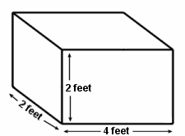

Stem: Which equation will show the volume in cubic feet?
Option A.
Option B.
Option C.
Option D.
Option E.
Key: B
RIT Range: 210 4.10.2
Copyright Info:
Idaho Content Alignment: 339.01.d
Learning Cont. Goal: Measurement
Learning Cont. Subgoal: Length, Weight, Volume
Learning Cont. Bullet #: 4
Learning Cont. Page #: 3
Idaho Falls Content Alignment: IF 7th+
Item Entry Complete: Y

Item ID Number: 30004520
Directions:
Passage or Graphic:

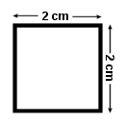

Stem: What is the correct equation to find the perimeter of the square?
Option A. 2cm + 2cm + 2cm = 6cm
Option B. 2cm 2cm = 4cm
Option C. 2cm + 2cm + 2cm + 2cm = 8cm
Option D. 2cm + 2cm = 4cm
Option E. 2cm 2cm = 1cm
Key: C
RIT Range: 210 4.5.1
Copyright Info:
Idaho Content Alignment: 341.01.e
Learning Cont. Goal: Measurement
Learning Cont. Subgoal: Area, Perimeter, Circumference
Learning Cont. Bullet #: 1
Learning Cont. Page #: 3
Idaho Falls Content Alignment: IF 4-135 & 5-68
Item Entry Complete: Y

Item ID Number: 30004530
Directions:
Passage or Graphic:

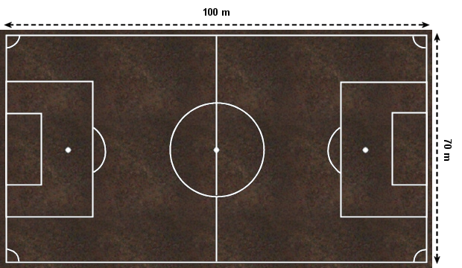

Stem: If 1 gram of grass seed is needed to plant 1 square meter, how many grams of grass seed will be needed to plant the entire soccer field?
Option A. 100
Option B. 70
Option C. 170
Option D. 5000
Option E. 7000
Key: E
RIT Range: 210 calc 216 non 4.3.1
Copyright Info:
Idaho Content Alignment: 338.01.a & 341.01.e
Learning Cont. Goal: Measurement
Learning Cont. Subgoal: Area, Perimeter, Circumference
Learning Cont. Bullet #: 2
Learning Cont. Page #: 3
Idaho Falls Content Alignment: IF 4-135 & 5-68(perimeter), 4-136 (area of a polygon), 5-108 (problem solve)
Item Entry Complete: Y

Item ID Number: 30004540
Directions:
Passage or Graphic:

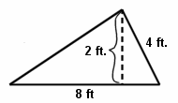

Stem: What is the area of the triangle in square feet?
Option A. 8
Option B. 20
Option C. 16
Option D. 10
Option E. 32
Key: A
RIT Range: 210 4.3.3
Copyright Info:
Idaho Content Alignment: 341.01.e
Learning Cont. Goal: Measurement
Learning Cont. Subgoal: Area, Perimeter, Circumference
Learning Cont. Bullet #: 3
Learning Cont. Page #: 3
Idaho Falls Content Alignment: IF 4-136
Item Entry Complete: Y

Item ID Number: 30004550
Directions:
Passage or Graphic:

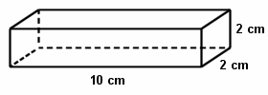

Stem: What is the surface area in square centimeters?
Option A. 20
Option B. 88
Option C. 40
Option D. 14
Option E. 112
Key: B
RIT Range: 210 4.3.5
Copyright Info:
Idaho Content Alignment: 341.01.f
Learning Cont. Goal: Measurement
Learning Cont. Subgoal: Area, Perimeter, Circumference
Learning Cont. Bullet #: 4
Learning Cont. Page #: 3
Idaho Falls Content Alignment: IF 7th+
Item Entry Complete: N - rit level is too low

Item ID Number: 30004560
Directions:
Passage or Graphic:
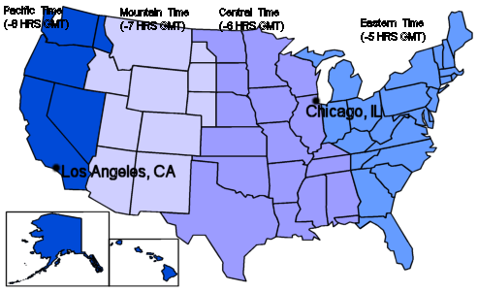

Stem: If it is 4:00pm in Chicago, what time is it in Los Angeles?
Option A. 4:00pm
Option B. 6:00pm
Option C. 2:00pm
Option D. 3:00pm
Option E. 5:00pm
Key: C
RIT Range: 210 4.6.1
Copyright Info:
Idaho Content Alignment: “None”
Learning Cont. Goal: Measurement
Learning Cont. Subgoal: Time, Temperature
Learning Cont. Bullet #: 1
Learning Cont. Page #: 3
Idaho Falls Content Alignment: “None”
Item Entry Complete: Y

Item ID Number: 30004570
Directions:
Passage or Graphic:

A.

B.

C.

D.

E.

Stem: Which diagram shows an obtuse angle?
Option A. A.
Option B. B.
Option C. C.
Option D. D.
Option E. E.
Key: D
RIT Range: 210 3.11.8
Copyright Info:
Idaho Content Alignment: 341.01.b
Learning Cont. Goal: Measurement
Learning Cont. Subgoal: Angle Identification and Measurement
Learning Cont. Bullet #: 1
Learning Cont. Page #: 3
Idaho Falls Content Alignment: IF 6-122(draw angles) & 6-71 (measure angles)
Item Entry Complete: Y

Item ID Number: 30004580
Directions:
Passage or Graphic:
Stem: If Yvonne had $5.00 and spent $3.79, what combination of bills and coins would equal the left over change?
Option A. 1 one-dollar bill, 1 dime, and 1 penny
Option B. 3 quarters, 4 dimes, 2 nickels and 3 pennies
Option C. 2 one-dollar bills, 7 dimes, and 9 pennies
Option D. 3 one-dollar bills, 3 quarters, and 4 pennies
Option E. 1 one-dollar bill, 2 dimes and 1 penny
Key: E
RIT Range: 210 4.7.1
Copyright Info:
Idaho Content Alignment: “None”
Learning Cont. Goal: Measurement
Learning Cont. Subgoal: Money
Learning Cont. Bullet #: 1
Learning Cont. Page #: 3
Idaho Falls Content Alignment: IF 3-131 (up to $10.00) & 2-108 (doesn’t say amt.)

Item Entry Complete: Y

Item ID Number: 30004590
Directions:
Passage or Graphic:
Stem: If Nicholas has $3.87 already and earns $7.92, how much does he have altogether?
Option A. $11.90
Option B. $14.05
Option C. $11.79
Option D. $10.80
Option E. $11.95
Key: C
RIT Range: 210 4.7.1
Copyright Info:
Idaho Content Alignment: 337.02.a
Learning Cont. Goal: Measurement
Learning Cont. Subgoal: Money
Learning Cont. Bullet #: 2
Learning Cont. Page #: 3
Idaho Falls Content Alignment: IF 5-66 (word problems using decimals)
Item Entry Complete: Y

Item ID Number: 30004600
Directions:
Passage or Graphic:

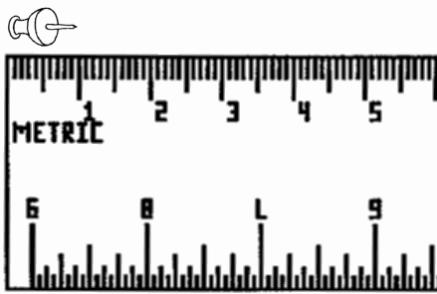

Stem: What is the length of this tack?
Option A. 1 centimeter
Option B. 2 centimeter
Option C. 5 centimeter
Option D. 1 meter
Option E. 1 millimeter
Key: A
RIT Range: 190 4.1.4
Copyright Info:
Idaho Content Alignment: 339.01.a
Learning Cont. Goal: Measurement
Learning Cont. Subgoal: Length, Weight, Volume
Learning Cont. Bullet #: 1
Learning Cont. Page #: 4
Idaho Falls Content Alignment: Grade 6, Abacus #70
Item Entry Complete: Y

Item ID Number: 30004610
Directions: Calculate the area of this shape.
Passage or Graphic:

5 ft.
0.5 ft.

Stem:
Option A. 5.5 ft
Option B. 2.5 ft²
Option C. 25 ft²
Option D. 0.25 ft²
Option E. 2.5 ft
Key: B
RIT Range: 211 4.3.3
Copyright Info:
Idaho Content Alignment: “None”
Learning Cont. Goal: Measurement
Learning Cont. Subgoal: Area, Perimeter, Circumference
Learning Cont. Bullet #: 1
Learning Cont. Page #: 4
Idaho Falls Content Alignment: “None”
Item Entry Complete: Y

Item ID Number: 30004620
Directions:
Passage or Graphic:
Stem: What happens to the perimeter when the length of a rectangle is shortened?
Option A. The perimeter stays the same.
Option B. The perimeter becomes greater.
Option C. The perimeter becomes smaller.
Option D. The perimeter is decreased by half.
Option E. The perimeter is increased by half.
Key: C
RIT Range: 211 4.5.1
Copyright Info:
Idaho Content Alignment: “None”
Learning Cont. Goal: Measurement
Learning Cont. Subgoal: Area, Perimeter, Circumference
Learning Cont. Bullet #: 2
Learning Cont. Page #: 4
Idaho Falls Content Alignment: “None”
Item Entry Complete: Y

Item ID Number: 30004630
Directions:
Passage or Graphic:

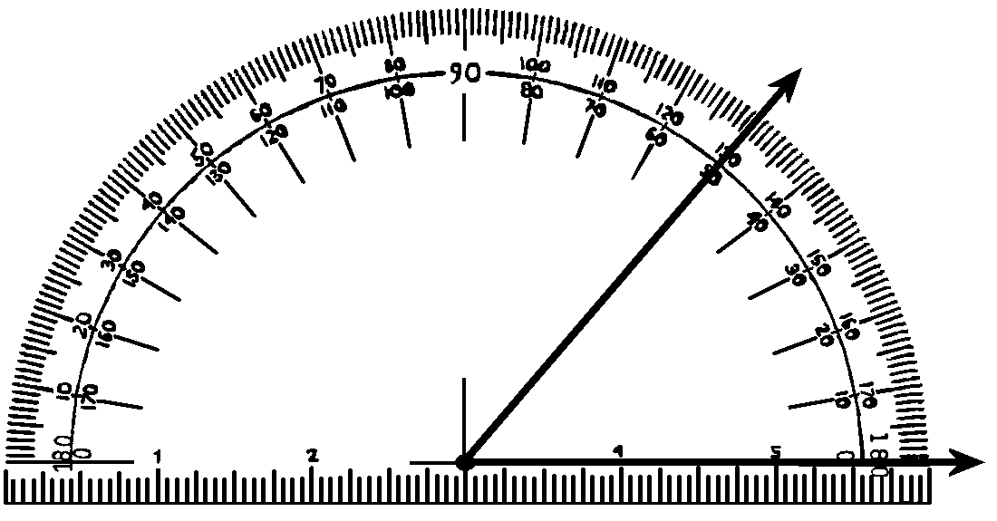

Stem: What is the measure of the angle shown?
Option A. 180°
Option B. 80°
Option C. 150°
Option D. 50°
Option E. 30°
Key: D
RIT Range: 211 4.2.5
Copyright Info:
Idaho Content Alignment: “None”
Learning Cont. Goal: Measurement
Learning Cont. Subgoal: Angle Measure
Learning Cont. Bullet #: 1
Learning Cont. Page #: 4
Idaho Falls Content Alignment: I.F. Grade 6 Abacus #71
Item Entry Complete: Y

Item ID Number: 30004640
Directions:
Passage or Graphic:
Stem: If Jamaal will be paid $5.00 an hour for delivering pizzas, and he works for 4 hours, how much will he be paid?
Option A. $9.00
Option B. $5.00
Option C. 20
Option D. $2.00
Option E. $20.00
Key: E
RIT Range: 211 4.7.1
Copyright Info:
Idaho Content Alignment: “None”
Learning Cont. Goal: Measurement
Learning Cont. Subgoal: Money
Learning Cont. Bullet #: 1
Learning Cont. Page #: 4
Idaho Falls Content Alignment: IF Grade 5 Abacus #38, 40, 42, 44
Item Entry Complete: Y

Item ID Number: 30004650
Directions:
Passage or Graphic:

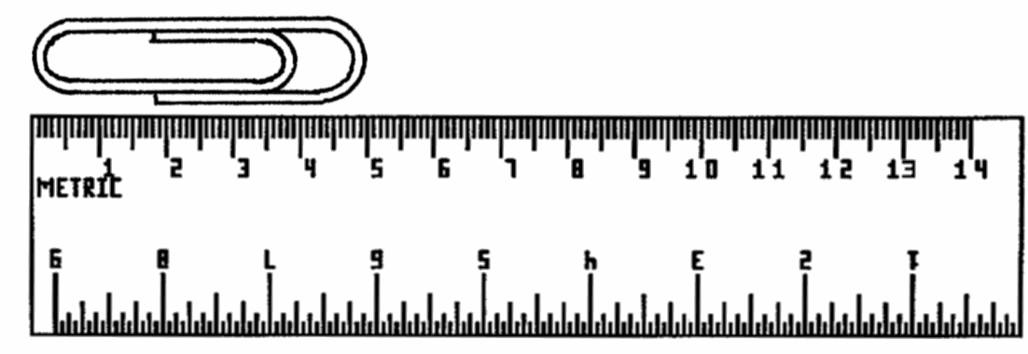

Stem: What is the length of the paper clip?
Option A. 5 cm
Option B. 5 mm
Option C. 3 cm
Option D. 4 cm
Option E. 4 mm
Key: A
RIT Range: 200 4.1.4
Copyright Info:
Idaho Content Alignment: 339.01.a
Learning Cont. Goal: Measurement
Learning Cont. Subgoal: Length, weight, volume
Learning Cont. Bullet #: 1
Learning Cont. Page #: 4
Idaho Falls Content Alignment: IF Grade 6 Abacus #70
Item Entry Complete: Y

Item ID Number: 30004660
Directions:
Passage or Graphic:

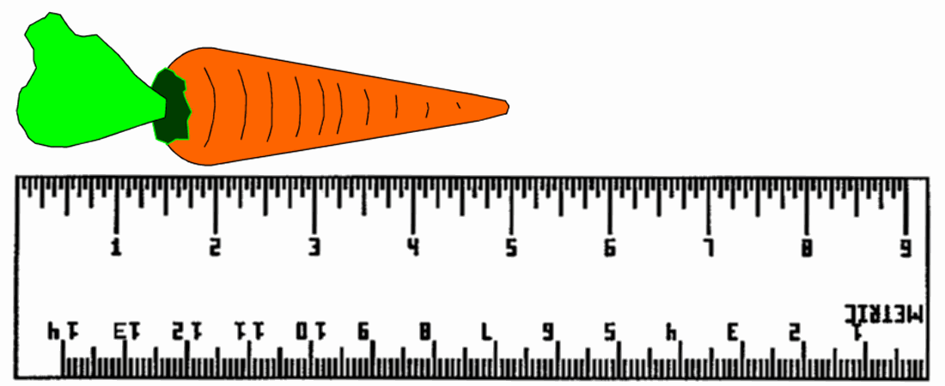

Stem: The total length of this carrot is how many inches?
Option A. 5.5″
Option B. 5″
Option C. 5 yds.
Option D. 0.5″
Option E. 5′
Key: B
RIT Range: 200 4.1.2
Copyright Info:
Idaho Content Alignment: 339.01.a
Learning Cont. Goal: Measurement
Learning Cont. Subgoal: Length, weight, measurement
Learning Cont. Bullet #: 2
Learning Cont. Page #: 4
Idaho Falls Content Alignment: IF Grade 6 Abacus #70
Item Entry Complete: Y

Item ID Number: 30004670
Directions:
Passage or Graphic:
Stem: If you were asked to calculate the length of a football field, what unit would you use?
Option A. quarts
Option B. inches
Option C. yards
Option D. centimeters
Option E. miles
Key: C
RIT Range: 210 4.1.2
Copyright Info:
Idaho Content Alignment: 339.01.a
Learning Cont. Goal: Measurement
Learning Cont. Subgoal: Length, weight, measurement
Learning Cont. Bullet #: 3
Learning Cont. Page #: 4
Idaho Falls Content Alignment: IF Grade 6 Abacus #70
Item Entry Complete: Y

Item ID Number: 30004680
Directions:
Passage or Graphic:

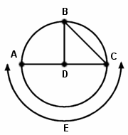

Stem: Which represents a radius?
Option A.
Option B.
Option C.
Option D.
Option E.
Key: C
RIT Range: 221 4.4.5
Copyright Info:
Idaho Content Alignment: “None”
Learning Cont. Goal: Measurement
Learning Cont. Subgoal: Area, Perimeter, Circumference
Learning Cont. Bullet #: 1
Learning Cont. Page #: 4
Idaho Falls Content Alignment: “None”
Item Entry Complete: Y

Item ID Number: 30004710
Directions:
Passage or Graphic:

10"
2"

Stem: What is the perimeter of this rectangle?
Option A. 12″
Option B. 24″
Option C. 8″
Option D. 16″
Option E. 20″
Key: B
RIT Range: 210 4.5.2
Copyright Info:
Idaho Content Alignment: 341.01.c
Learning Cont. Goal: Measurement
Learning Cont. Subgoal: Area, Perimeter, Circumference
Learning Cont. Bullet #: 1
Learning Cont. Page #: 4
Idaho Falls Content Alignment: IF Grade 6 Abacus #88
Item Entry Complete: Y

Item ID Number: 30004720
Directions:
Passage or Graphic:

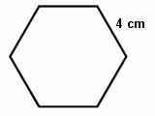

Stem: What is the perimeter of this regular hexagon?
Option A. 16 cm²
Option B. 24 cm
Option C. 8 cm
Option D. 36 cm²
Option E. 40 cm
Key: B
RIT Range: 220 4.5.2
Copyright Info:
Idaho Content Alignment: “None”
Learning Cont. Goal: Measurement
Learning Cont. Subgoal: Area, Perimeter, Circumference
Learning Cont. Bullet #: 2
Learning Cont. Page #: 4
Idaho Falls Content Alignment: “None”
Item Entry Complete: Y

Item ID Number: 30004730
Directions: Find the area of this parallelogram.
Passage or Graphic:

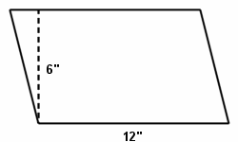

Stem:
Option A. 96 in
Option B. 18 in²
Option C. 68 in²
Option D. 72 in²
Option E. 96 in²
Key: D
RIT Range: 231 4.3.3
Copyright Info:
Idaho Content Alignment: 339.01.c
Learning Cont. Goal: Measurement
Learning Cont. Subgoal: Area, Perimeter, Circumference
Learning Cont. Bullet #: 3
Learning Cont. Page #: 4
Idaho Falls Content Alignment: “None”
Item Entry Complete: Y

Item ID Number: 30004740
Directions: Find the area of this triangle.
Passage or Graphic:

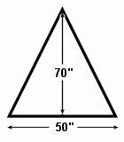

Stem:
Option A. 1,200 in
Option B. 3,500 in²
Option C. 120 in
Option D. 1,200 in²
Option E. 1,750 in²
Key: E
RIT Range: 231 4.3.3
Copyright Info:
Idaho Content Alignment: 339.01.c
Learning Cont. Goal: Measurement
Learning Cont. Subgoal: Area, Perimeter, Circumference
Learning Cont. Bullet #: 4
Learning Cont. Page #: 4
Idaho Falls Content Alignment: “None”
Item Entry Complete: Y

Item ID Number: 30004750
Directions: Use the formula C=pd and p=3.14.
Passage or Graphic:

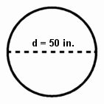

Stem: Find the circumference of this circle to the nearest inch.
Option A. 157 in.
Option B. 150 in.
Option C. 1,570 in.
Option D. 53.14 in.
Option E. 46.86 in.
Key: A
RIT Range: 231 4.4.4
Copyright Info:
Idaho Content Alignment: 341.01.e
Learning Cont. Goal: Measurement
Learning Cont. Subgoal: Area, Perimeter, Circumference
Learning Cont. Bullet #: 5
Learning Cont. Page #: 4
Idaho Falls Content Alignment: IF Gr 6 Abacus #87
Item Entry Complete: Y

Item ID Number: 30004760
Directions:
Passage or Graphic:
Stem: Which of the following statements is true?
Option A. 0º Celsius = 0º Fahrenheit
Option B. 0º Celsius = 32º Fahrenheit
Option C. 32º Celsius = 32º Fahrenheit
Option D. Celsius and Fahrenheit never record the same temperature.
Option E. Celsius increases by 5’s and Fahrenheit by ones.
Key: B
RIT Range: 231 4.8.2
Copyright Info:
Idaho Content Alignment: 339.01.d
Learning Cont. Goal: Measurement
Learning Cont. Subgoal: Time, Temperature
Learning Cont. Bullet #: 1
Learning Cont. Page #: 4
Idaho Falls Content Alignment: “None”
Item Entry Complete: Y

Item ID Number: 30004770
Directions: Subtract Fahrenheit temperature.
Passage or Graphic: 212ºF
- 197ºF

Stem:
Option A. 35º F
Option B. 15º C
Option C. 185º C
Option D. 15º F
Option E. 409º F
Key: D
RIT Range: 220 4.8.1
Copyright Info:
Idaho Content Alignment: 339.01.d
Learning Cont. Goal: Measurement
Learning Cont. Subgoal: Time, Temperature
Learning Cont. Bullet #: 1
Learning Cont. Page #: 5
Idaho Falls Content Alignment: “None”
Item Entry Complete: Y

Item ID Number: 30004780
Directions:
Passage or Graphic:
Stem: Isaac works at a furniture store. He earns $129.00 per week plus a commission of $25.00 per couch that he sells. Last week he sold 3 couches. How much money did he earn last week?
Option A. $129.00
Option B. $204.00
Option C. $154.00
Option D. $54.00
Option E. $75.00
Key: B
RIT Range: 220 4.7.1
Copyright Info:
Idaho Content Alignment: 339.04.a, 349.04.a
Learning Cont. Goal: Measurement
Learning Cont. Subgoal: Money
Learning Cont. Bullet #: 1
Learning Cont. Page #: 5
Idaho Falls Content Alignment: “None”
Item Entry Complete: Y

Item ID Number: 30004790
Directions:
Passage or Graphic:
Stem: Zoe had $47.32 and spent $19.45. What combination of bills and coins represents the correct amount of change Zoe would receive?
Option A. 5 five-dollar bills, 2 one-dollar bills, 3 quarters, and 12 pennies
Option B. 1 ten-dollar bill, 2 five-dollar bills and 3 nickels
Option C. 4 five-dollar bills, 7 one-dollar bills, 3 quarters, 3 nickels, and 7 pennies
Option D. 1 twenty-dollar bill, 7 one-dollar bills, 4 quarters, and 2 dimes
Option E. 1 ten-dollar bill, 1 five-dollar bill, 4 one-dollar bills, 4 dimes, and 5 pennies
Key: A
RIT Range: 220 4.7.1
Copyright Info:
Idaho Content Alignment: 337.02.a, 347.01.a
Learning Cont. Goal: Measurement
Learning Cont. Subgoal: Money
Learning Cont. Bullet #: 2
Learning Cont. Page #: 5
Idaho Falls Content Alignment: “None”
Item Entry Complete: Y

Item ID Number: 30004800
Directions:
Passage or Graphic:

x | x | 1 | 1 | 1 | 1
x | x | 1 | 1 | 1 | 1
x | x | 1 | 1 | 1 | 1
x | x | 1 | 1 | 1 | 1

Stem: Calculate the area of this rectangle using the illustrated algebra tiles.
Option A. 8x + 16
Option B. 4x + 20
Option C. 6x + 16
Option D. 8x +14
Option E. 6x + 14
Key: A
RIT Range: 241 4.3.7
Copyright Info:
Idaho Content Alignment: 349.01.a
Learning Cont. Goal: Measurement
Learning Cont. Subgoal: Area, Perimeter, Circumference
Learning Cont. Bullet #: 1
Learning Cont. Page #: 5
Idaho Falls Content Alignment: “None”
Item Entry Complete: Y

Item ID Number: 30004810
Directions: Complete the sentence.
Passage or Graphic:

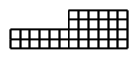

Stem: If all sides are increased by 1 square unit, then the perimeter of the shape will ________________.
Option A. decrease by 6 square units
Option B. increase by 7 square units
Option C. decrease by 7 square units
Option D. decrease by 4 square units
Option E. increase by 4 square units
Key: B
RIT Range: 241 4.5.1
Copyright Info:
Idaho Content Alignment: “None”
Learning Cont. Goal: Measurement
Learning Cont. Subgoal: Area, Perimeter, Circumference
Learning Cont. Bullet #: 2
Learning Cont. Page #: 5
Idaho Falls Content Alignment: “None”
Item Entry Complete: Y

Item ID Number: 30004820
Directions:
Passage or Graphic:

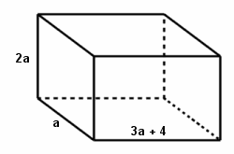

Stem: Which formula could be used to calculate the surface area of this rectangular prism?
Option A. S = 24 a² + 22
Option B. S = 22a² + 24a
Option C. S = 22a + 24a
Option D. S = 20a + 22a
Option E. S = 22a² + 20a
Key: B
RIT Range: 241 4.11
Copyright Info:
Idaho Content Alignment: 349.01.a
Learning Cont. Goal: Measurement
Learning Cont. Subgoal: Area, Perimeter, Circumference
Learning Cont. Bullet #: 3
Learning Cont. Page #: 5
Idaho Falls Content Alignment: #91 Algebra 2
Item Entry Complete: Y

Item ID Number: 30004830
Directions:
Passage or Graphic:
Stem: Find the volume of a cone with radius 5 and slant height 12.
Option A. 100π
Option B. 300π
Option C. 325π
3
Option D. 20π
Option E. 169π
3
Key: A
RIT Range: 251non 245 calc 4.10.1
Copyright Info:
Idaho Content Alignment: 341.01.f
Learning Cont. Goal: Measurement
Learning Cont. Subgoal: Length, Weight, Volume
Learning Cont. Bullet #: 1
Learning Cont. Page #: 5
Idaho Falls Content Alignment: District #91: 291335
Item Entry Complete: Y

Item ID Number: 30004840
Directions:
Passage or Graphic:
Stem: A circle is inscribed in a square. The points of tangency are (-2, 7), (2, 3), (6, 7), and (2, 11). Find the area of the circle.
Option A. 50.27
Option B. 201.06
Option C. 12.57
Option D. 153.94
Option E. 113.10
Key: A
RIT Range: 251 non 245 calc 4.4.1
Copyright Info:
Idaho Content Alignment: 341.01.e
Learning Cont. Goal: Measurement
Learning Cont. Subgoal: Area, Perimeter, Circumference
Learning Cont. Bullet #: 1
Learning Cont. Page #: 5
Idaho Falls Content Alignment: District #91, 291333
Item Entry Complete: Y

Item ID Number: 30004850
Directions:
Passage or Graphic:
Stem: Which of the following lengths of segments could be used to form a triangle?
Option A. 5, 6, 10
Option B. 5, 6, 11
Option C. 5, 6, 12
Option D. 6, 10, 16
Option E. 6, 10, 20
Key: A
RIT Range: 251 3.7.1
Copyright Info:
Idaho Content Alignment: 341.01.a
Learning Cont. Goal: Measurement
Learning Cont. Subgoal: Angle, Identification and Measure
Learning Cont. Bullet #: 1
Learning Cont. Page #: 5
Idaho Falls Content Alignment: #91--291370
Item Entry Complete: Y

Item ID Number: 30004870
Directions:
Passage or Graphic:
Stem: The height of a cylinder is twice the length of the diameter. The diameter has a length of 8. Find the surface area of the cylinder.
Option A. 160π
Option B. 384π
Option C. 128π
Option D. 256π
Option E. 144π
Key: A
RIT Range: 261 non 255 calc 4.3.1
Copyright Info:
Idaho Content Alignment: “None”
Learning Cont. Goal: Measurement
Learning Cont. Subgoal: Area, Perimeter, Circumference
Learning Cont. Bullet #: 2
Learning Cont. Page #: 5
Idaho Falls Content Alignment: 291334
Item Entry Complete: Y

Item ID Number: 30004880
Directions:
Passage or Graphic:

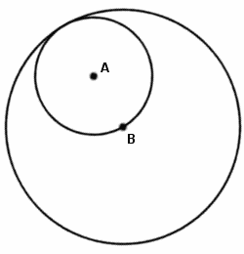

Stem: If the area of circle A is 36π, find the diameter of circle B.
Option A. 24
Option B. 12
Option C. 18
Option D. 30
Option E. 48
Key: A
RIT Range: 261 4.4.1
Copyright Info:
Idaho Content Alignment: 341.01.e
Learning Cont. Goal: Measurement
Learning Cont. Subgoal: Area, Perimeter, Circumference
Learning Cont. Bullet #: 3
Learning Cont. Page #: 5
Idaho Falls Content Alignment: 291333
Item Entry Complete: Y

Item ID Number: 30004890
Directions:
Passage or Graphic:

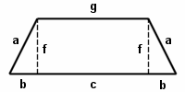

Stem: Find the perimeter of the trapezoid.
Option A. 2a + 2b + c + g
Option B. a + 2b + c + g
Option C. 2a + 2f + c + g
Option D. 2a + b + c + f
Option E. 2a + 2b + 2f + g
Key: A
RIT Range: 261 4.5.2
Copyright Info:
Idaho Content Alignment: 341.01.e
Learning Cont. Goal: Measurement
Learning Cont. Subgoal: Area, Perimeter, Circumference
Learning Cont. Bullet #: 4
Learning Cont. Page #: 5
Idaho Falls Content Alignment: 291333
Item Entry Complete: Y

Item ID Number: 30004900
Directions:
Passage or Graphic:
Stem: Given a cylinder with a diameter of 8.5 units and a height of five times the radius, find the volume of the cylinder.
Option A. 1262.58 cu units
Option B. 5050.31 cu units
Option C. 9646.65 cu units
Option D. 401.89 cu units
Option E. 2525.15 cu units
Key: A
RIT Range: 271 calc 277 non 4.10.1
Copyright Info:
Idaho Content Alignment: “None”
Learning Cont. Goal: Measurement
Learning Cont. Subgoal: Length, Weight, Volume
Learning Cont. Bullet #: 1
Learning Cont. Page #: 5
Idaho Falls Content Alignment: #91--291335
Item Entry Complete: Y

Item ID Number: 30004910
Directions:
Passage or Graphic:
Stem: A $240.00 item is discounted 1/6 of its price. Then a further discount of 1/3 is taken. What is the cost of the item?
Option A. $133.33
Option B. $140.33
Option C. $200.00
Option D. $120.66
Option E. $210.00
Key: A
RIT Range: 271non 265 calc 4.7.1
Copyright Info:
Idaho Content Alignment: “None”
Learning Cont. Goal: Measurement
Learning Cont. Subgoal: Money
Learning Cont. Bullet #: 1
Learning Cont. Page #: 5
Idaho Falls Content Alignment: 291449
Item Entry Complete: Y

Item ID Number: 30004920
Directions:
Passage or Graphic:

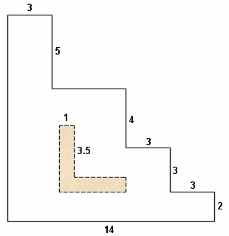

Stem: What is the ratio of the area of the shaded region to the area of the entire figure?
Option A.
Option B.
Option C.
Option D.
Option E.
Key: A
RIT Range: 281non 275 calc 8.5
Copyright Info:
Idaho Content Alignment: 349.03.a
Learning Cont. Goal: Measurement
Learning Cont. Subgoal: Area, Perimeter, Circumference
Learning Cont. Bullet #: 1
Learning Cont. Page #: 6
Idaho Falls Content Alignment: #91--291333
Item Entry Complete: Y

