Item ID Number: 30004930
Directions:
Passage or Graphic:

Time Spent on Favorite Activities

Fishing | 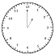
Reading
Softball
Video Games

= 1 hr.

Stem: How much more time is spent on fishing than reading?
Option A. 1 hour
Option B. 2 hours
Option C. 3 hours
Option D. 4 hours
Option E. 5 hours
Key: A
RIT Range: 160 Goal 6.3
Copyright Info:
Idaho Content Alignment: 302.01.a
Learning Cont. Goal: Statistics and Probability
Learning Cont. Subgoal: Graphing
Learning Cont. Bullet #: 1
Learning Cont. Page #: 1
Idaho Falls Content Alignment: Gr. Level 2, 3, 4; Abacus 163, 206, 218
Item Entry Complete: Y

Item ID Number: 30004940
Directions:
Passage or Graphic:

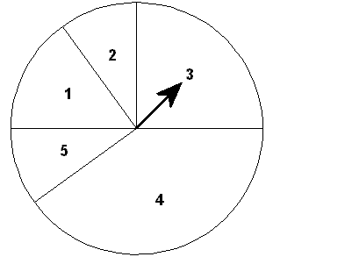

Stem: On which number is the spinner most likely to land?
Option A. 1
Option B. 2
Option C. 3
Option D. 4
Option E. 5
Key: D
RIT Range: 170 Goal 5.1.2
Copyright Info:
Idaho Content Alignment: 302.05.a
Learning Cont. Goal: Statistics and Probability
Learning Cont. Subgoal: Probability and Prediction
Learning Cont. Bullet #: 1
Learning Cont. Page #: 1
Idaho Falls Content Alignment: “None”
Item Entry Complete: Y

Item ID Number: 30004950
Directions:
Passage or Graphic:

Dogs Adopted

September | 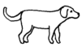
October
November
December

Each |  | stands for one dog.

Stem: How many dogs were adopted in September and November?
Option A. 6
Option B. 5
Option C. 4
Option D. 3
Option E. 7
Key: B
RIT Range: 165 Goal 6.3
Copyright Info:
Idaho Content Alignment: 302.01.a
Learning Cont. Goal: Statistics and Probability
Learning Cont. Subgoal: Graphing
Learning Cont. Bullet #: 1
Learning Cont. Page #: 1
Idaho Falls Content Alignment: Gr. 3, 4; Abacus 218, 206
Item Entry Complete: Y

Item ID Number: 30004960
Directions:
Passage or Graphic:

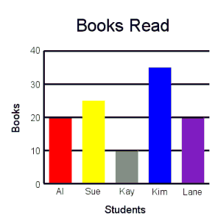

Stem: Who read the most books?
Option A. Lane
Option B. Kay
Option C. Sue
Option D. Kim
Option E. Al
Key: D
RIT Range: 165 Goal 6.7
Copyright Info:
Idaho Content Alignment: 302.01.a
Learning Cont. Goal: Statistics and Probability
Learning Cont. Subgoal: Graphing
Learning Cont. Bullet #: 2
Learning Cont. Page #: 1
Idaho Falls Content Alignment: Gr. 2, 3; Abacus 163, 206
Item Entry Complete: Y

Item ID Number: 30004970
Directions:
Passage or Graphic:

Bags of Food Collected
Monday | 
Tuesday
Wednesday
Thursday
Friday
Saturday

Each |  | stands for five bags.

Stem: How many bags do you think will be collected on Friday?
Option A. 60
Option B. 14
Option C. 6
Option D. 30
Option E. 25
Key: D
RIT Range: 180 Goal 6.3
Copyright Info:
Idaho Content Alignment: 302.01.b
Learning Cont. Goal: Statistics and Probability
Learning Cont. Subgoal: Probability / Prediction
Learning Cont. Bullet #: 1
Learning Cont. Page #: 1
Idaho Falls Content Alignment: Gr. 3, Abacus 206
Item Entry Complete: Y

Item ID Number: 30004980
Directions:
Passage or Graphic:



Stem: Look at the pattern. How many stars will go in the last row?
Option A. 4
Option B. 5
Option C. 6
Option D. 3
Option E. 13
Key: B
RIT Range: 165 Goal 7.5.3
Copyright Info:
Idaho Content Alignment: 302.1.a
Learning Cont. Goal: Statistics and Probability
Learning Cont. Subgoal: Probability / Prediction
Learning Cont. Bullet #: 2
Learning Cont. Page #: 1
Idaho Falls Content Alignment: Gr. 5, Abacus 106
Item Entry Complete: Y

Item ID Number: 30004990
Directions:
Passage or Graphic:

Cupcakes Sold

Monday | 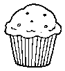
Tuesday
Wednesday
Thursday
Friday

Key: |  | = 5 cupcakes

Stem: How many cupcakes were sold on Wednesday?
Option A. 52
Option B. 15
Option C. 3
Option D. 25
Option E. 5
Key: D
RIT Range: 180 Goal 6.3
Copyright Info:
Idaho Content Alignment: 302.01.a
Learning Cont. Goal: Statistics and Probability
Learning Cont. Subgoal: Graphing
Learning Cont. Bullet #: 1
Learning Cont. Page #: 1
Idaho Falls Content Alignment: Gr. 3, Abacus 206
Item Entry Complete: Y

Item ID Number: 30005000
Directions:
Passage or Graphic:

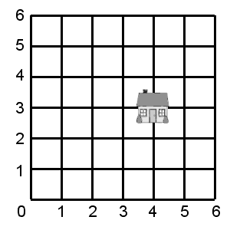

Stem: The house is at what point on the grid?
Option A. (4,4)
Option B. (2,2)
Option C. (4,2)
Option D. (3,2)
Option E. (3,4)
Key: C
RIT Range: 180 Goal 6.11.7
Copyright Info:
Idaho Content Alignment: 302.01.a
Learning Cont. Goal: Statistics and Probability
Learning Cont. Subgoal: Graphing
Learning Cont. Bullet #: 2
Learning Cont. Page #: 1
Idaho Falls Content Alignment: "None"
Item Entry Complete: Y

Item ID Number: 30005010
Directions:
Passage or Graphic:

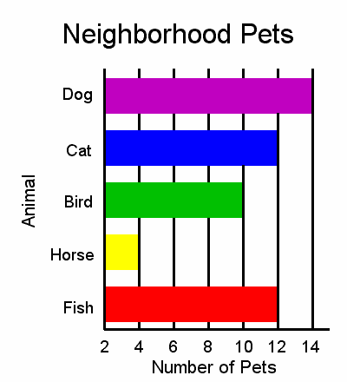

Stem: Most children have which pet?
Option A. Dog
Option B. Cat
Option C. Bird
Option D. Horse
Option E. Fish
Key: A
RIT Range: 180 Goal 6.7
Copyright Info:
Idaho Content Alignment: 302.01.a
Learning Cont. Goal: Statistics and Probability
Learning Cont. Subgoal: Graphing
Learning Cont. Bullet #: 3
Learning Cont. Page #: 1
Idaho Falls Content Alignment: Gr. 2, 3; Abacus 157, 206
Item Entry Complete: Y

Item ID Number: 30005020
Directions:
Passage or Graphic:

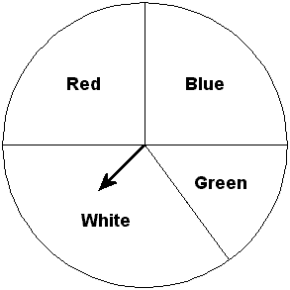

Stem: What is the likelihood of the spinner stopping on yellow?
Option A. Possible
Option B. Likely
Option C. Certain
Option D. Impossible
Option E. Unlikely
Key: D
RIT Range: 190 Goal 5.1.2
Copyright Info:
Idaho Content Alignment: 302.05.a
Learning Cont. Goal: Statistics and Probability
Learning Cont. Subgoal: Probability
Learning Cont. Bullet #: 1
Learning Cont. Page #: 1
Idaho Falls Content Alignment: Gr. 5; Abacus 106
Item Entry Complete: Y

Item ID Number: 30005030
Directions:
Passage or Graphic:

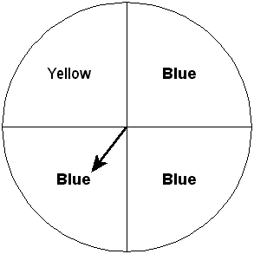

Stem: What are the odds of the spinner stopping on blue?
Option A. 1 to 3
Option B. 5 to 2
Option C. 1 to 2
Option D. 3 to 4
Option E. 3 to 1
Key: E
RIT Range: 190 Goal 5.1.2
Copyright Info:
Idaho Content Alignment: 302.05.a
Learning Cont. Goal: Statistics and Probability
Learning Cont. Subgoal: Probability
Learning Cont. Bullet #: 2
Learning Cont. Page #: 1
Idaho Falls Content Alignment: "None"
Item Entry Complete: Y

Item ID Number: 30005040
Directions:
Passage or Graphic:

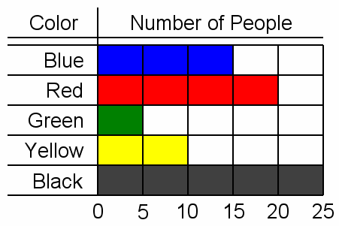

Stem: Which color was the favorite?
Option A. Red
Option B. Yellow
Option C. Black
Option D. Blue
Option E. Green
Key: C
RIT Range: 190 Goal 6.7
Copyright Info:
Idaho Content Alignment: 302.01.a
Learning Cont. Goal: Statistics and Probability
Learning Cont. Subgoal: Graphing
Learning Cont. Bullet #: 1
Learning Cont. Page #: 1
Idaho Falls Content Alignment: Gr. 2, 3, 4; Abacus 163, 206, 218
Item Entry Complete: Y

Item ID Number: 30005050
Directions:
Passage or Graphic:
Stem: Without looking, you pull out only one marble from a bag that has 5 red, 10 green, 5 yellow, 5 orange, and 5 blue marbles. Which color are you most likely to pull out?
Option A. Red
Option B. Green
Option C. Yellow
Option D. Orange
Option E. Blue
Key: B
RIT Range: 190 Goal 5.1
Copyright Info:
Idaho Content Alignment: 342.04.b
Learning Cont. Goal: Statistics and Probability
Learning Cont. Subgoal: Probability & Prediction
Learning Cont. Bullet #: 1
Learning Cont. Page #: 2
Idaho Falls Content Alignment: "None"
Item Entry Complete: Y

Item ID Number: 30005060
Directions:
Passage or Graphic:
Stem: In a survey of 30 seventh graders' favorite colors, 5 chose red, 10 chose blue, 7 chose green, and 8 chose yellow. What is the correct tally entry for green?
Option A. 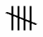
Option B.
Option C.
Option D.
Option E.
Key: B
RIT Range: 191 Goal 5.1
Copyright Info:
Idaho Content Alignment: 342.02.a
Learning Cont. Goal: Statistics and Probability
Learning Cont. Subgoal: Statistics
Learning Cont. Bullet #: 1
Learning Cont. Page #: 2
Idaho Falls Content Alignment: "None"
Item Entry Complete: Y

Item ID Number: 30005070
Directions:
Passage or Graphic:
Stem: Bill received the following scores on five tests: 90, 90, 80, 70, 70. What was his average test score?
Option A. 90
Option B. 85
Option C. 80
Option D. 75
Option E. 70
Key: C
RIT Range: 200 calc 206 non Goal 5.3.1
Copyright Info:
Idaho Content Alignment: 342.03.a
Learning Cont. Goal: Statistics and Probability
Learning Cont. Subgoal: Statistics
Learning Cont. Bullet #: 2
Learning Cont. Page #: 2
Idaho Falls Content Alignment: "None"
Item Entry Complete: Y

Item ID Number: 30005080
Directions:
Passage or Graphic:
Stem: How many different ways can the letters in the word MATH be arranged?
Option A. 4
Option B. 8
Option C. 12
Option D. 16
Option E. 24
Key: E
RIT Range: 210 Goal 5.2
Copyright Info:
Idaho Content Alignment: 342.04.b
Learning Cont. Goal: Statistics and Probability
Learning Cont. Subgoal: Combinations & Permutations
Learning Cont. Bullet #: 1
Learning Cont. Page #: 2
Idaho Falls Content Alignment: "None"
Item Entry Complete: Y

Item ID Number: 30005100
Directions:
Passage or Graphic:

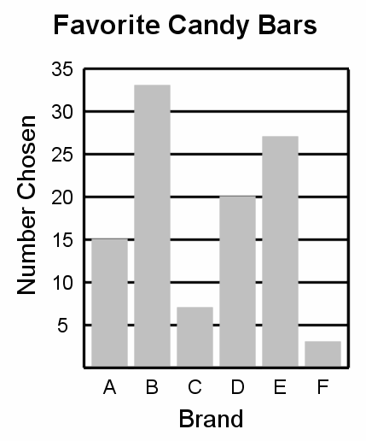

Stem: How many people chose brand E?
Option A. 7
Option B. 20
Option C. 15
Option D. 27
Option E. 33
Key: D
RIT Range: 200 Goal 6.7
Copyright Info:
Idaho Content Alignment: 342.01.a
Learning Cont. Goal: Statistics and Probability
Learning Cont. Subgoal: Graphing
Learning Cont. Bullet #: 2
Learning Cont. Page #: 2
Idaho Falls Content Alignment: "None"
Item Entry Complete: Y

Item ID Number: 30005110
Directions:
Passage or Graphic:

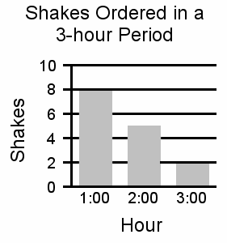

Stem: What is the average number of shakes ordered per hour?
Option A. 15
Option B. 10
Option C. 8
Option D. 5
Option E. 2
Key: D
RIT Range: 200 calc 206 non Goal 5.3.1
Copyright Info:
Idaho Content Alignment: 342.01.a, 342.03.a
Learning Cont. Goal: Statistics and Probability
Learning Cont. Subgoal: Graphing
Learning Cont. Bullet #: 3
Learning Cont. Page #: 2
Idaho Falls Content Alignment: "None"
Item Entry Complete: Y

Item ID Number: 30005120
Directions:
Passage or Graphic:

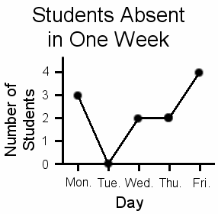

Stem: How many students were absent on Wednesday?
Option A. 0
Option B. 1
Option C. 2
Option D. 3
Option E. 4
Key: C
RIT Range: 200 Goal 6.1
Copyright Info:
Idaho Content Alignment: 342.01.a
Learning Cont. Goal: Statistics and Probability
Learning Cont. Subgoal: Graphing
Learning Cont. Bullet #: 4
Learning Cont. Page #: 2
Idaho Falls Content Alignment: "None"
Item Entry Complete: Y

Item ID Number: 30005130
Directions:
Passage or Graphic:

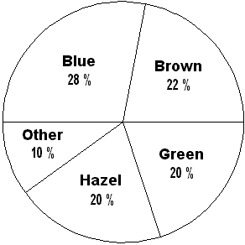

Stem: What is the most common eye color?
Option A. Blue
Option B. Brown
Option C. Green
Option D. Hazel
Option E. Other
Key: A
RIT Range: 200 Goal 6.10
Copyright Info:
Idaho Content Alignment: 342.01.a
Learning Cont. Goal: Statistics and Probability
Learning Cont. Subgoal: Graphing
Learning Cont. Bullet #: 5
Learning Cont. Page #: 2
Idaho Falls Content Alignment: "None"
Item Entry Complete: Y

Item ID Number: 30005140
Directions:
Passage or Graphic:

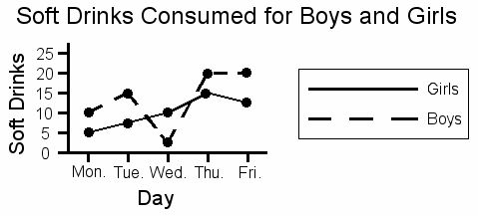

Stem: On which day did the boys drink fewer soft drinks than the girls?
Option A. Monday
Option B. Tuesday
Option C. Wednesday
Option D. Thursday
Option E. Friday
Key: C
RIT Range: 200 Goal 6.1
Copyright Info:
Idaho Content Alignment: 342.01.a
Learning Cont. Goal: Statistics and Probability
Learning Cont. Subgoal: Graphing
Learning Cont. Bullet #: 6
Learning Cont. Page #: 2
Idaho Falls Content Alignment: "None"
Item Entry Complete: Y

Item ID Number: 30005150
Directions:
Passage or Graphic:

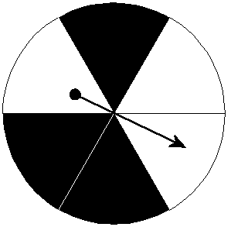

Stem: What are the chances of spinning black?
Option A. One in six
Option B. Three in four
Option C. One in three
Option D. Five in six
Option E. Three in six
Key: E
RIT Range: 210 Goal 5.1.2
Copyright Info:
Idaho Content Alignment: 342.04.a, 342.05.a, 302.04.a
Learning Cont. Goal: Statistics and Probability
Learning Cont. Subgoal: Probability & Prediction
Learning Cont. Bullet #: 1
Learning Cont. Page #: 2
Idaho Falls Content Alignment: "None"
Item Entry Complete: Y

Item ID Number: 30005160
Directions:
Passage or Graphic:

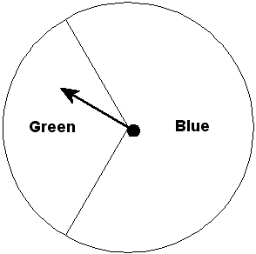

Stem: The spinner will:
Option A. usually land on blue.
Option B. always land on blue.
Option C. usually land on green.
Option D. always land on green.
Option E. never land on blue.
Key: A
RIT Range: 210 Goal 5.1.2
Copyright Info:
Idaho Content Alignment: 342.05.a, 302.04.a
Learning Cont. Goal: Statistics and Probability
Learning Cont. Subgoal: Probability & Prediction
Learning Cont. Bullet #: 2
Learning Cont. Page #: 2
Idaho Falls Content Alignment: Gr. 7+
Item Entry Complete: Y

Item ID Number: 30005170
Directions:
Passage or Graphic:

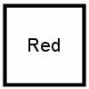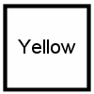

Stem: These squares are put into a bag. How often will a red one be pulled out of the bag?
Option A. 4 out of 7
Option B. 3 out of 7
Option C. 7 out of 7
Option D. 1 out of 7
Option E. 10 out of 7
Key: A
RIT Range: 210 Goal 5.2
Copyright Info:
Idaho Content Alignment: 302.04.a
Learning Cont. Goal: Statistics and Probability
Learning Cont. Subgoal: Probability & Prediction
Learning Cont. Bullet #: 3
Learning Cont. Page #: 2
Idaho Falls Content Alignment: "None"
Item Entry Complete: Y

Item ID Number: 30005180
Directions:
Passage or Graphic:
Stem: Sal sold 20 pizzas on Monday, 17 on Tuesday, and 23 on Wednesday. What is the average number of pizzas she sold?
Option A. 60
Option B. 30
Option C. 23
Option D. 17
Option E. 20
Key: E
RIT Range: 210 calc 216 non Goal 5.3.1
Copyright Info:
Idaho Content Alignment: 302.03.a, 342.03.a
Learning Cont. Goal: Statistics and Probability
Learning Cont. Subgoal: Statistics
Learning Cont. Bullet #: 1
Learning Cont. Page #: 2
Idaho Falls Content Alignment: "None"
Item Entry Complete: Y

Item ID Number: 30005190
Directions:
Passage or Graphic:

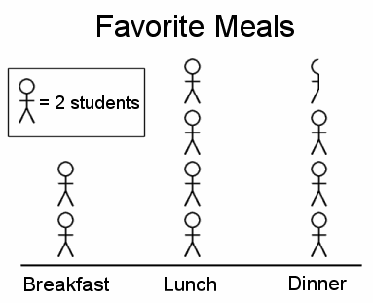

Stem: How many students chose lunch as their favorite meal?
Option A. 7
Option B. 2
Option C. 4
Option D. 8
Option E. 3
Key: D
RIT Range: 210 Goal 6.3
Copyright Info:
Idaho Content Alignment: 302.02.a
Learning Cont. Goal: Statistics and Probability
Learning Cont. Subgoal: Graphing
Learning Cont. Bullet #: 1
Learning Cont. Page #: 2
Idaho Falls Content Alignment: Gr. 2, 3, 4; Abacus 163, 206
Item Entry Complete: Y

Item ID Number: 30005200
Directions:
Passage or Graphic:

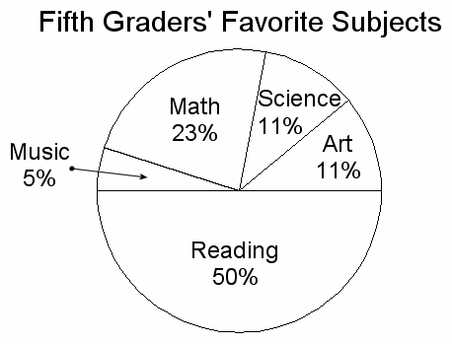

Stem: Which is a true statement about the graph?
Option A. More than half the students chose math.
Option B. The least number of students chose art.
Option C. Half of the students chose reading.
Option D. The greatest number of students chose science.
Option E. Half of the students chose music.
Key: C
RIT Range: 210 Goal 6.10
Copyright Info:
Idaho Content Alignment: 342.01.a, 337.01.a
Learning Cont. Goal: Statistics and Probability
Learning Cont. Subgoal: Graphing
Learning Cont. Bullet #: 2
Learning Cont. Page #: 2
Idaho Falls Content Alignment: Gr. 5; Abacus 94
Item Entry Complete: Y

Item ID Number: 30005210
Directions:
Passage or Graphic:

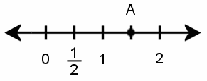

Stem: What is the value of point A on the number line?
Option A.
Option B.
Option C.
Option D.
Option E.
Key: B
RIT Range: 210 Goal 6.2.2
Copyright Info:
Idaho Content Alignment: 337.01.a, 337.01.e
Learning Cont. Goal: Statistics and Probability
Learning Cont. Subgoal: Graphing
Learning Cont. Bullet #: 1
Learning Cont. Page #: 2
Idaho Falls Content Alignment: "None"
Item Entry Complete: Y

Item ID Number: 30005220
Directions:
Passage or Graphic:

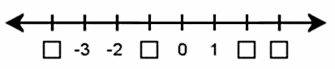

Stem: The missing numbers, from least to greatest, are:
Option A. -4, 4, -1, 3
Option B. -1, -4, 3, 4
Option C. 4, 3, -1, -4
Option D. -4, -3, 1, 2
Option E. -4, -1, 2, 3
Key: E
RIT Range: 220 Goal 6.2.4
Copyright Info:
Idaho Content Alignment: 337.01.e
Learning Cont. Goal: Statistics and Probability
Learning Cont. Subgoal: Graphing
Learning Cont. Bullet #: 2
Learning Cont. Page #: 2
Idaho Falls Content Alignment: "None"
Item Entry Complete: Y

Item ID Number: 30005230
Directions:
Passage or Graphic:

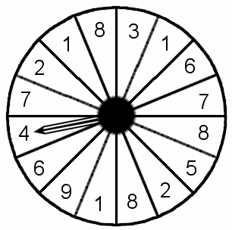

Stem: What is the probability of spinning an even number?
Option A. 1/2
Option B. 3/4
Option C. 1
Option D. 7/16
Option E. 2/3
Key: A 342.04.b, 342.05.c
RIT Range: 221 Goal 5.1.2
Copyright Info:
Idaho Content Alignment: "None"
Learning Cont. Goal: Statistics and Probability
Learning Cont. Subgoal: Probability & Prediction
Learning Cont. Bullet #: 1
Learning Cont. Page #: 2
Idaho Falls Content Alignment: "None"
Item Entry Complete: Y

Item ID Number: 30005240
Directions:
Passage or Graphic:
Stem: Compute the mean, median & mode for the following set of data: {7, 6, 2, 2, 3, 2, 7, 3}
Option A.
mean = 4
median = 3
mode = 3
Option B.
mean = 32
median = 3
mode = 8
Option C.
mean = 8
median = 6
mode = 7
Option D.
mean = 4
median = 3
mode = 2
Option E.
mean = 32
median = 6
mode = 8
Key: D
RIT Range: 230 non 224 calc Goal 5.3
Copyright Info:
Idaho Content Alignment: 342.03.a
Learning Cont. Goal: Statistics and Probability
Learning Cont. Subgoal: Statistics
Learning Cont. Bullet #: 1
Learning Cont. Page #: 3
Idaho Falls Content Alignment: "None"
Item Entry Complete: Y

Item ID Number: 30005260
Directions:
Passage or Graphic:

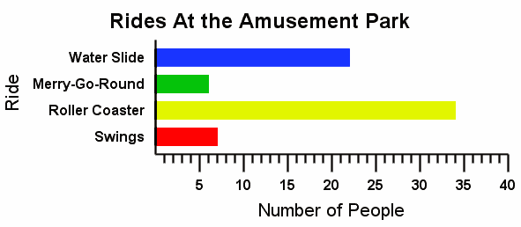

Stem: How many more people went on the water slide and roller coaster than the merry-go-round and swings?
Option A. 42
Option B. 55
Option C. 13
Option D. 68
Option E. 9
Key: A
RIT Range: 221 Goal 6.7
Copyright Info:
Idaho Content Alignment: 342.01.a
Learning Cont. Goal: Statistics and Probability
Learning Cont. Subgoal: Graphing
Learning Cont. Bullet #: 1
Learning Cont. Page #: 3
Idaho Falls Content Alignment: "None"
Item Entry Complete: Y

Item ID Number: 30005270
Directions:
Passage or Graphic:
Stem: Find the range, mean, median and mode of the following: {6, 5, 10, 4, 5, 3, 2}
Option A.
range = 10
mean = 35
median = 5
mode = 5
Option B.
range = 10
mean = 5
median = 5
mode = 10
Option C.
range = 8
mean = 35
median = 5
mode = 10
Option D.
range = 10
mean = 35
median = 8
mode = 10
Option E.
range = 8
mean = 5
median = 5
mode = 5
Key: E
RIT Range: 231 calc 237 non Goal 5.3
Copyright Info:
Idaho Content Alignment: 342.03.a
Learning Cont. Goal: Statistics and Probability
Learning Cont. Subgoal: Statistics
Learning Cont. Bullet #: 1
Learning Cont. Page #: 3
Idaho Falls Content Alignment: "None"
Item Entry Complete: Y

Item ID Number: 30005280
Directions:
Passage or Graphic:

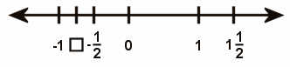

Stem: What is the missing value?
Option A.
Option B.
Option C.
Option D.
Option E.
Key: A
RIT Range: 231 Goal 6.2.2
Copyright Info:
Idaho Content Alignment: 337.01.e
Learning Cont. Goal: Statistics and Probability
Learning Cont. Subgoal: Graphing
Learning Cont. Bullet #: 1
Learning Cont. Page #: 3
Idaho Falls Content Alignment: "None"
Item Entry Complete: Y

Item ID Number: 30005290
Directions:
Passage or Graphic:

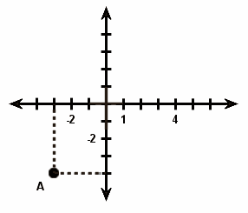

Stem: What is the coordinate of point A?
Option A. (2, -4)
Option B. (3, -4)
Option C. (-3, -4)
Option D. (-3, 4)
Option E. (-4, -3)
Key: C
RIT Range: 221 Goal 6.11.7
Copyright Info:
Idaho Content Alignment: 341.02.a
Learning Cont. Goal: Statistics and Probability
Learning Cont. Subgoal: Graphing
Learning Cont. Bullet #: 2
Learning Cont. Page #: 3
Idaho Falls Content Alignment: "None"
Item Entry Complete: Y

Item ID Number: 30005300
Directions:
Passage or Graphic:
Stem: Order these numbers from least to greatest:
Option A.
Option B.
Option C.
Option D.
Option E.
Key: D
RIT Range: 231 Goal 2.4
Copyright Info:
Idaho Content Alignment: 337.01.a
Learning Cont. Goal: Statistics and Probability
Learning Cont. Subgoal: Graphing
Learning Cont. Bullet #: 2
Learning Cont. Page #: 3
Idaho Falls Content Alignment: "None"
Item Entry Complete: Y

Item ID Number: 30005310
Directions:
Passage or Graphic:

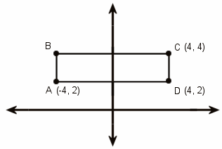

Stem: What is the coordinate of point B?
Option A. (-4, -4)
Option B. (4, -4)
Option C. (-4, 4)
Option D. (2, -4)
Option E. (-2, 4)
Key: C
RIT Range: 231 Goal 6.11.7
Copyright Info:
Idaho Content Alignment: 341.02.a
Learning Cont. Goal: Statistics and Probability
Learning Cont. Subgoal: Graphing
Learning Cont. Bullet #: 3
Learning Cont. Page #: 3
Idaho Falls Content Alignment: "None"
Item Entry Complete: Y

Item ID Number: 30005320
Directions:
Passage or Graphic:

Stem: What is the missing value of y?
Option A. 4
Option B. 3
Option C. 1
Option D. 0
Option E. -1
Key: B
RIT Range: 231 Goal 7.3.3
Copyright Info:
Idaho Content Alignment: 343.01.b
Learning Cont. Goal: Statistics and Probability
Learning Cont. Subgoal: Graphing
Learning Cont. Bullet #: 4
Learning Cont. Page #: 3
Idaho Falls Content Alignment: "None"
Item Entry Complete: Y

Item ID Number: 30005330
Directions:
Passage or Graphic:
Stem: What is the probability of rolling a number less than five on one toss of a six-sided die?
Option A. 4
Option B.
Option C. 6
Option D.
Option E.
Key: B
RIT Range: 241 Goal 5.1.1
Copyright Info:
Idaho Content Alignment: 342.04.b
Learning Cont. Goal: Statistics and Probability
Learning Cont. Subgoal: Probability & Prediction
Learning Cont. Bullet #: 1
Learning Cont. Page #: 3
Idaho Falls Content Alignment: "None"
Item Entry Complete: Y

Item ID Number: 30005350
Directions:
Passage or Graphic:

8th Grade Fundraiser
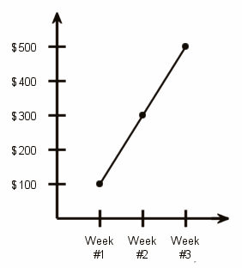

Stem: If the trend continues, how much money will they have raised at the end of week #5?
Option A. $700
Option B. $900
Option C. $600
Option D. $500
Option E. $1000
Key: B
RIT Range: 230 Goal 6.1
Copyright Info:
Idaho Content Alignment: 342.01.a
Learning Cont. Goal: Statistics and Probability
Learning Cont. Subgoal: Graphing
Learning Cont. Bullet #: 1
Learning Cont. Page #: 3
Idaho Falls Content Alignment: "None"
Item Entry Complete: Y

Item ID Number: 30005360
Directions:
Passage or Graphic:

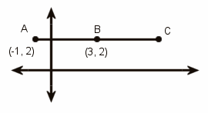

Stem: If point B is the midpoint of segment , what are the coordinates of point C?
Option A. (8, 2)
Option B. (2, 7)
Option C. (2, 6)
Option D. (6, 2)
Option E. (7, 2)
Key: E
RIT Range: 240 Goal 6.11.10
Copyright Info:
Idaho Content Alignment: 351.03.a
Learning Cont. Goal: Statistics and Probability
Learning Cont. Subgoal: Graphing
Learning Cont. Bullet #: 2
Learning Cont. Page #: 3
Idaho Falls Content Alignment: "None"
Item Entry Complete: Y

Item ID Number: 30005370
Directions:
Passage or Graphic:

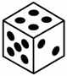

Stem: A fair six-sided die is rolled 36 times. How many times should the number 4 be expected to come up?
Option A. 6
Option B. 4
Option C. 2
Option D. 9
Option E. 8
Key: A
RIT Range: 251 Goal 5.1.1
Copyright Info:
Idaho Content Alignment: 352.04.a, 342.05.a
Learning Cont. Goal: Statistics and Probability
Learning Cont. Subgoal: Probability & Prediction
Learning Cont. Bullet #: 1
Learning Cont. Page #: 3
Idaho Falls Content Alignment: "None"
Item Entry Complete: Y

Item ID Number: 30005380
Directions:
Passage or Graphic:
Stem: Which of these equations represents the line through points (-1, 2) and (-2, 5)?
Option A.
Option B.
Option C.
Option D.
Option E.
Key: A
RIT Range: 251 Goal 6.11.4
Copyright Info:
Idaho Content Alignment: 350.03.a
Learning Cont. Goal: Statistics and Probability
Learning Cont. Subgoal: Graphing
Learning Cont. Bullet #: 1
Learning Cont. Page #: 3
Idaho Falls Content Alignment: "None"
Item Entry Complete: Y

Item ID Number: 30005390
Directions:
Passage or Graphic:
Stem: What is the area of figure ABCD with vertices A(-5, 3), B(1, 3), C(4, -1), D(-2, -1)?
Option A. 24 square units
Option B. 30 square units
Option C. 12 square units
Option D. 20 square units
Option E. 18 square units
Key: A
RIT Range: 251 Goal 6.11.3
Copyright Info:
Idaho Content Alignment: 339.01.d
Learning Cont. Goal: Statistics and Probability
Learning Cont. Subgoal: Graphing
Learning Cont. Bullet #: 2
Learning Cont. Page #: 3
Idaho Falls Content Alignment: "None"
Item Entry Complete: Y

Item ID Number: 30005400
Directions:
Passage or Graphic:

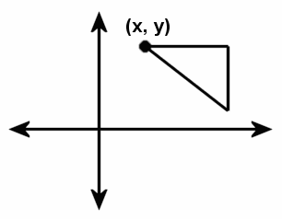

Stem: The figure in the diagram is reflected over the y-axis. What is the new coordinate of point (x, y)?
Option A. (-x, -y)
Option B. (-x, y)
Option C. (x, -y)
Option D. (y, x)
Option E. (-y, -x)
Key: B
RIT Range: 240 Goal 6.11.6
Copyright Info:
Idaho Content Alignment: 341.01.g
Learning Cont. Goal: Statistics and Probability
Learning Cont. Subgoal: Graphing
Learning Cont. Bullet #: 1
Learning Cont. Page #: 4
Idaho Falls Content Alignment: Abacus 91
Item Entry Complete: Y
Too many A’s
Item ID Number: 30005410
Directions:
Passage or Graphic:

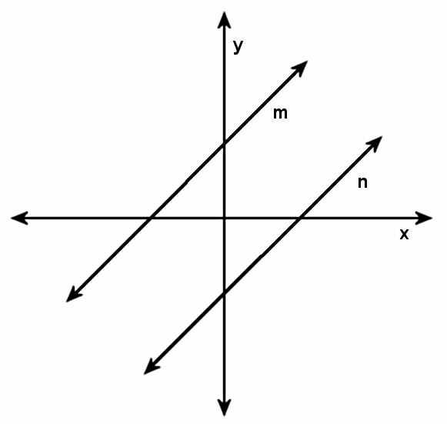

Stem: What is the line of symmetry of line m?
Option A. y = x
Option B. y = -x
Option C. y = 0
Option D. x = 0
Option E. line n
Key: B
RIT Range: 251 Goal 6.11.5
Copyright Info:
Idaho Content Alignment: 341.01.c
Learning Cont. Goal: Statistics and Probability
Learning Cont. Subgoal: Graphing
Learning Cont. Bullet #: 2
Learning Cont. Page #: 4
Idaho Falls Content Alignment: “None”
Item Entry Complete: Y

Item ID Number: 30005420
Directions:
Passage or Graphic:
Stem: If you toss a nickel, a dime, a red die, and a green die, which of these expressions represents the probability for getting a head on the nickel, a tail on the dime, a 3 on the red die, and a 5 on the green die?
Option A.
Option B.
Option C.
Option D.
Option E.
Key: A
RIT Range: 285 Goal 5.1
Copyright Info:
Idaho Content Alignment: 342.05.a, 352.04.a
Learning Cont. Goal: Statistics and Probability
Learning Cont. Subgoal: Combinations & Permutations
Learning Cont. Bullet #: 1
Learning Cont. Page #: 4
Idaho Falls Content Alignment: Abacus 91
Item Entry Complete: Y

Item ID Number: 30005430
Directions:
Passage or Graphic:
Stem: Given a square pyramid with side 10 feet and lateral height 12 feet. If the lateral height is doubled, what will be the change in volume? Round to the nearest cubic foot.
Option A. 433 cubic feet
Option B. 850 cubic feet
Option C. 400 cubic feet
Option D. 450 cubic feet
Option E. 833 cubic feet
Key: D
RIT Range: 285 calc 291 non Goal 8.5
Copyright Info:
Idaho Content Alignment: 341.01.f
Learning Cont. Goal: Statistics and Probability
Learning Cont. Subgoal: Graphing
Learning Cont. Bullet #: 1
Learning Cont. Page #: 4
Idaho Falls Content Alignment: Abacus 91
Item Entry Complete: Y

